highlighting, where items selected in one view are highlighted in all others. In linked navigation, movement in one view triggers movement in the others.

There are many kinds of multiple-view approaches. In what is usually called simply the *multiple-view* approach, the same data is shown in several views, each of which has a different visual encoding that shows certain aspects of the dataset most clearly. The power of linked highlighting across multiple visual encodings is that items that fall in a contiguous region in one view are often distributed very differently in the other views. In the *small-multiples* approach, each view has the same visual encoding for different datasets, usually with shared axes between frames so that comparison of spatial position between them is meaningful. Side- by-side comparison with small multiples is an alternative to the visual clutter of superimposing all the data in the same view, and to the human memory limitations of remembering previously seen frames in an animation that changes over time.

The *overview-and-detail* approach is to have the same data and the same visual encoding in two views, where the only difference between them is the level of zooming. In most cases, the overview uses much less display space than the detail view. The combination of overview and detail views is common outside of visualization in many tools ranging from mapping software to photo editing. With a *detail-on-demand* approach, another view shows more information about some selected item, either as a popup window near the cursor or in a permanent window in another part of the display.

Determining the most appropriate spatial position of the views themselves with respect to each other can be as significant a problem as determining the spatial position of marks within a single view. In some systems, the location of the views is arbitrary and left up to the window system or the user. Aligning the views allows precise comparison between them, either vertically, horizontally, or with an array for both directions. Just as items can be sorted within a view, views can be sorted within a display, typically with respect to a derived variable measuring some aspect of the entire view as opposed to an individual item within it.

Figure 26.16 shows a visualization of census data that uses many views. In addition to geographic information, the demographic information for each county includes population, density, gender, median age, percent change since 1990, and proportions of major ethnic groups. The visual encodings used include ge- ographic, scatterplot, parallel coordinate, tabular, and matrix views. The same color encoding is used across all the views, with a legend in the bottom middle. The scatterplot matrix shows linked highlighting across all views, where the blue items are close together in some views and scattered in others. The map in the upper-left corner is an overview for the large detail map in the center. The tabular views allow direct sorting by and selection within a dimension of interest.

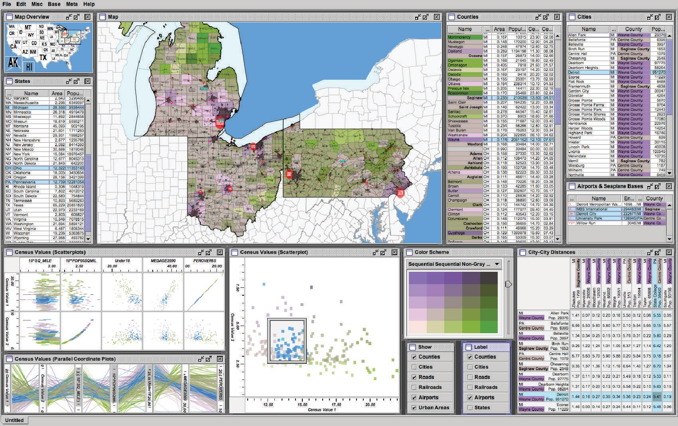

**Figure 26.16.** The Improvise toolkit was used to create this multiple-view visualization. *Image courtesy Chris Weaver.*

# Data Reduction

The visual encoding techniques that we have discussed so far show all of the items in a dataset. However, many datasets are so large that showing everything simul- taneously would result in so much visual clutter that the visual representation would be difficult or impossible for a viewer to understand. The main strategies to reduce the amount of data shown are overviews and aggregation, filtering and navigation, the focus+context techniques, and dimensionality reduction.

* + 1. Overviews and Aggregation

With tiny datasets, a visual encoding can easily show all data dimensions for all items. For datasets of medium size, an overview that shows information about all items can be constructed by showing less detail for each item. Many datasets have internal or derivable structure at multiple scales. In these cases, a multiscale visual representation can provide many levels of overview, rather than just a single

level. Overviews are typically used as a starting point to give users clues about where to drill down to inspect in more detail.

For larger datasets, creating an overview requires some kind of visual sum- marization. One approach to data reduction is to use an *aggregate* representation where a single visual mark in the overview explicitly represents many items.

The challenge of aggregation is to avoid eliminating the interesting signals in the dataset in the process of summarization. In the cartographic literature, the problem of creating maps at different scales while retaining the important dis- tinguishing characteristics has been extensively studied under the name of *carto- graphic generalization* (Slocum, McMaster, Kessler, & Howard, 2008).

* + 1. Filtering and Navigation

Another approach to data reduction is to *filter* the data, showing only a subset of the items. Filtering is often carried out by directly selecting ranges of interest in one or more of the data dimensions.

Navigation is a specific kind of filtering based on spatial position, where changing the viewpoint changes the visible set of items. Both geometric and non- geometric zooming are used in visualization. With geometric zooming, the cam- era position in 2D or 3D space can be changed with standard computer graphics controls. In a realistic scene, items should be drawn at a size that depends on their distance from the camera, and only their apparent size changes based on that dis- tance. However, in a visual encoding of an abstract space, nongeometric zooming can be useful. In *semantic zooming*, the visual appearance of an object changes dramatically based on the number of pixels available to draw it. For instance, an abstract visual representation of a text file could change from a tiny color-coded box with no label to a medium-sized box containing only the filename as a text label to a large rectangle containing a multi-line summary of the file contents. In realistic scenes, objects that are sufficiently far away from the camera are not vis- ible in the images, for example, after they subtend less than one pixel of screen area. With *guaranteed visibility*, one of the original or derived data dimensions is used as a measure of importance, and objects of sufficient importance must have some kind of representation visible in the image plane at all times.

* + 1. Focus+Context

*Focus+context* techniques are another approach to data reduction. A subset of the dataset items are interactively chosen by the user to be the focus and are drawn

in detail. The visual encoding also includes information about some or all of the rest of the dataset shown for context, integrated into the same view that shows the focus items. Many of these techniques use carefully chosen distortion to combine magnified focus regions and minified context regions into a unified view.

One common interaction metaphor is a moveable fisheye lens. Hyperbolic geometry provides an elegant mathematical framework for a single radial lens that affects all objects in the view. Another interaction metaphor is to use mul- tiple lenses of different shapes and magnification levels that affect only local re- gions. Stretch and squish navigation uses the interaction metaphor of a rubber sheet where stretching one region squishes the rest, as shown in Figure 26.17. The borders of the sheet stay fixed so that all items are within the viewport, al- though many items may be compressed to subpixel size. The fisheye metaphor is not limited to a geometric lens used after spatial layout; it can be used directly on structured data, such as a hierarchical document where some sections are col- lapsed while others are left expanded.

These distortion-based approaches are another example of nonliteral naviga- tion in the same spirit as nongeometric zooming. When navigating within a large and unfamiliar dataset with realistic camera motion, users can become disori-

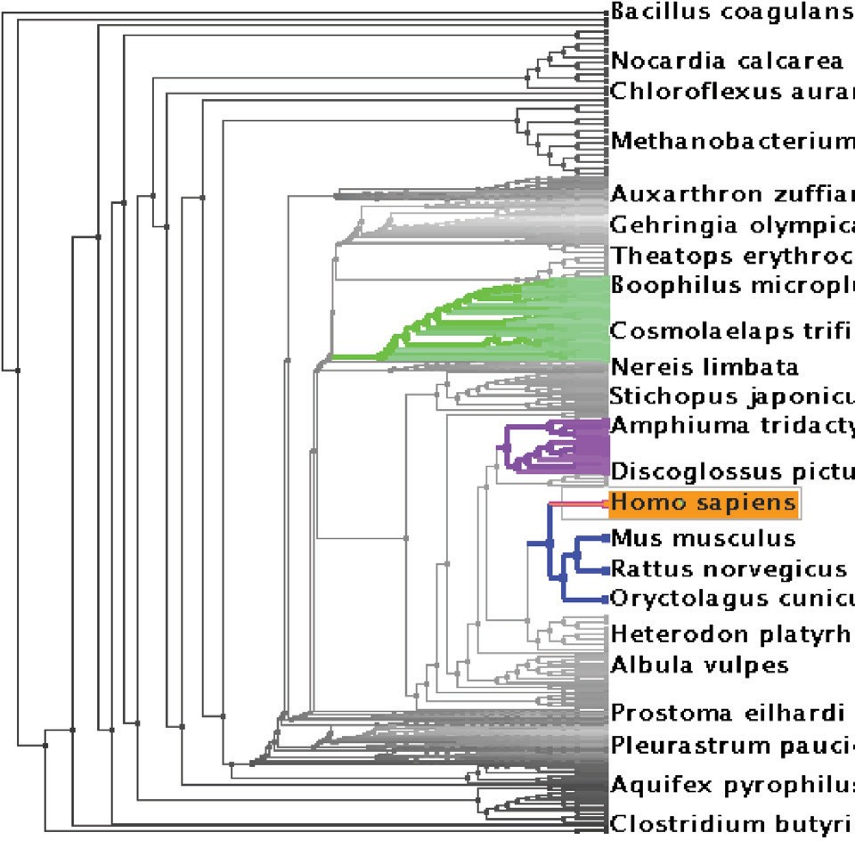

**Figure 26.17.** The TreeJuxtaposer system features stretch and squish navigation and guaranteed visibility of regions marked with colors (Munzner, Guimbretie`re, Tasiran, Zhang, & Zhou, 2003).

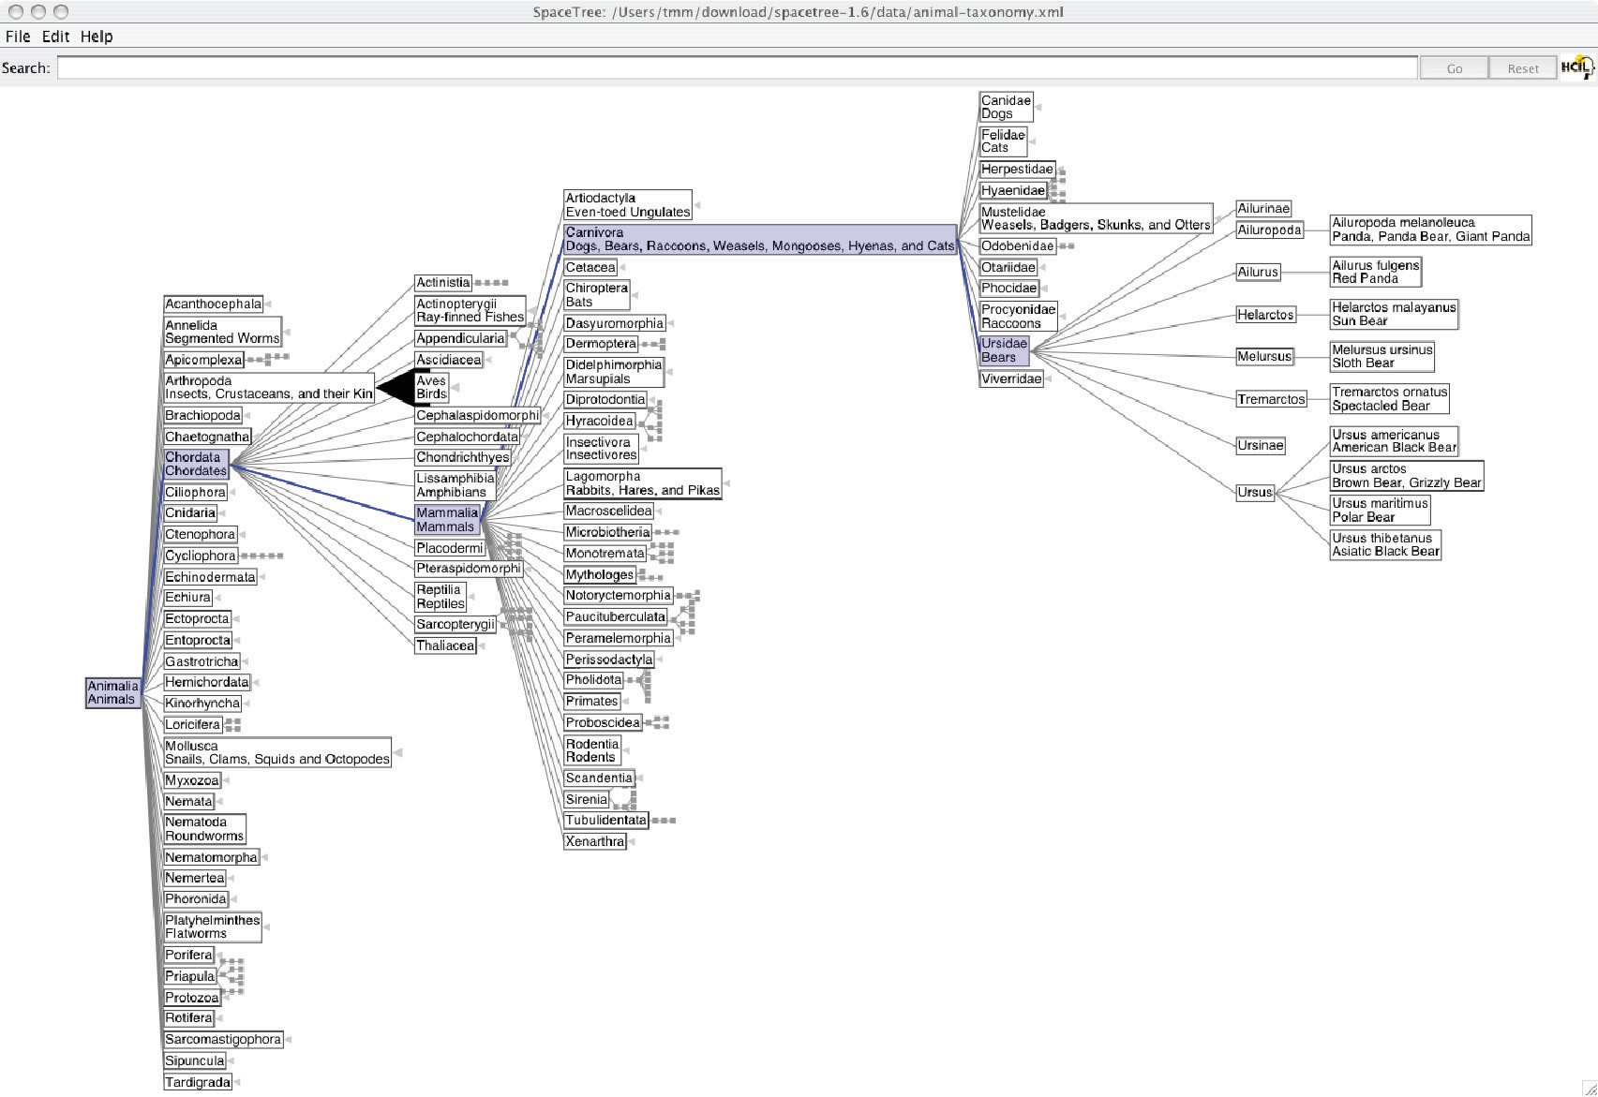

**Figure 26.18.** The SpaceTree system shows the path between the root and the interactively chosen focus node to provide context (Grosjean, Plaisant, & Bederson, 2002).

ented at high zoom levels when they can see only a small local region. These approaches are designed to provide more contextual information than a single undistorted view, in hopes that people can stay oriented if landmarks remain rec- ognizeable. However, these kinds of distortion can still be confusing or difficult to follow for users. The costs and benefits of distortion, as opposed to multiple views or a single realistic view, are not yet fully understood. Standard 3D per- spective is a particularly familiar kind of distortion and was explicitly used as a form of focus+context in early visualization work. However, as the costs of 3D spatial layout discussed in Section 26.4 became more understood, this approach became less popular.

Other approaches to providing context around focus items do not require dis- tortion. For instance, the SpaceTree system shown in Figure 26.18 elides most nodes in the tree, showing the path between the interactively chosen focus node and the root of the tree for context.

* + 1. Dimensionality Reduction

The data reduction approaches covered so far reduce the number of items to draw. When there are many data dimensions, *dimensionality reduction* can also be ef- fective.

With *slicing*, a single value is chosen from the dimension to eliminate, and only the items matching that value for the dimension are extracted to include in the lower-dimensional slice. Slicing is particularly useful with 3D spatial data, for example when inspecting slices through a CT scan of a human head at different heights along the skull. Slicing can be used to eliminate multiple dimensions at once.

With *projection*, no information about the eliminated dimensions is retained; the values for those dimensions are simply dropped, and all items are still shown. A familiar form of projection is the standard graphics perspective transformation which projects from 3D to 2D, losing information about depth along the way. In mathematical visualization, the structure of higher-dimensional geometric objects can be shown by projecting from 4D to 3D before the standard projection to the image plane and using color to encode information from the projected-away di- mension. This technique is sometimes called *dimensional filtering* when it is used for nonspatial data.

In some datasets, there may be interesting hidden structure in a much lower- dimensional space than the number of original data dimensions. For instance, sometimes directly measuring the independent variables of interest is difficult or

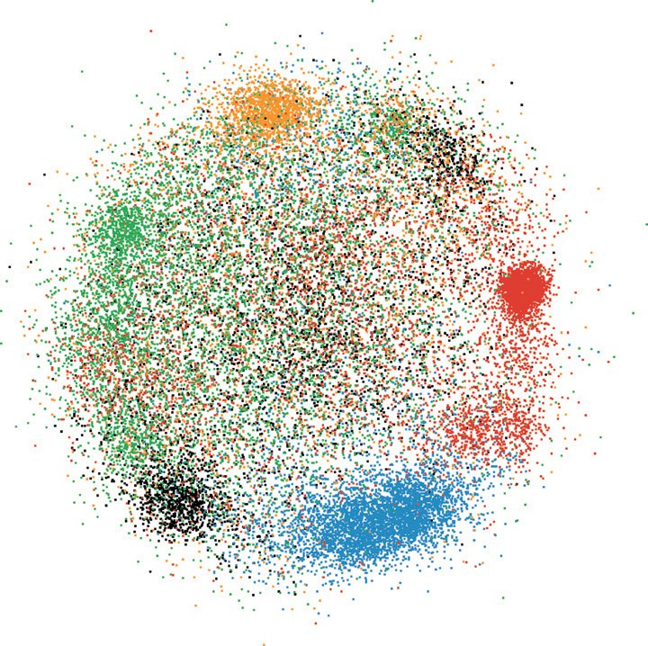

**Figure 26.19.** Dimensionality reduction with the Glimmer multidimensional scaling approach shows clusters in a document dataset (Ingram, Munzner, & Olano, 2009), © 2009 IEEE.

impossible, but a large set of dependent or indirect variables is available. The goal is to find a small set of dimensions that faithfully represent most of the structure or variance in the dataset. These dimensions may be the original ones, or synthesized new ones that are linear or nonlinear combinations of the originals. Principal com- ponent analysis is a fast, widely used linear method. Many nonlinear approaches have been proposed, including multidimensional scaling (MDS). These methods are usually used to determine whether there are large-scale clusters in the dataset; the fine-grained structure in the lower-dimensional plots is usually not reliable because information is lost in the reduction. Figure 26.19 shows document col- lection in a single scatterplot. When the true dimensionality of the dataset is far higher than two, a matrix of scatterplots showing pairs of synthetic dimensions may be necessary.

# Examples

We conclude this chapter with several examples of visualizing specific types of data using the techniques discussed above.

* + 1. Tables

Tabular data is extremely common, as all spreadsheet users know. The goal in visualization is to encode this information through easily perceivable visual channels rather than forcing people to read through it as numbers and text. Fig- ure 26.20 shows the Table Lens, a focus+context approach where quantitative values are encoded as the length of one-pixel high lines in the context regions, and shown as numbers in the focus regions. Each dimension of the dataset is shown as a column, and the rows of items can be resorted according to the values in that column with a single click in its header.

The traditional Cartesian approach of a scatterplot, where items are plotted as dots with respect to perpendicular axes, is only usable for two and three dimen- sions of data. Many tables contain far more than three dimensions of data, and the number of additional dimensions that can be encoded using other visual channels is limited. Parallel coordinates are an approach for visualizing more dimensions at once using spatial position, where the axes are parallel rather than perpendic- ular and an *n*-dimensional item is shown as a polyline that crosses each of the *n* axes once (Inselberg & Dimsdale, 1990; Wegman, 1990). Figure 26.21 shows an eight-dimensional dataset of 230,000 items at multiple levels of detail (Fua, Ward, & Rundensteiner, 1999), from a high-level view at the top to finer detail

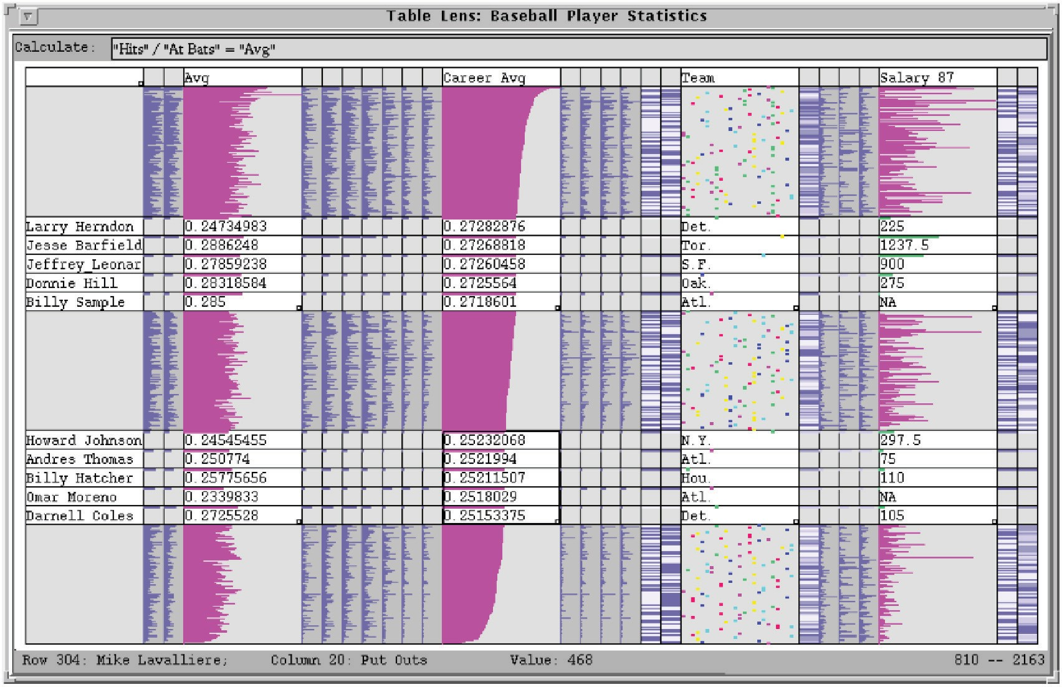

**Figure 26.20.** The Table Lens provides focus+context interaction with tabular data, immediately reorderable by the values in each dimension column. *Image courtesy Stuart Card* (Rao & Card, 1994),

© 1994 ACM, Inc. Included here by permission.

at the bottom. With hierarchical parallel coordinates, the items are clustered and an entire cluster of items is represented by a band of varying width and opacity, where the mean is in the middle and width at each axis depends on the values of the items in the cluster in that dimension. The coloring of each band is based on the proximity between clusters according to a similarity metric.

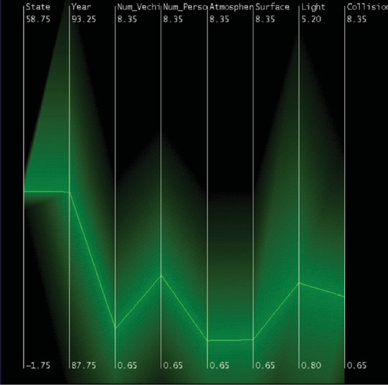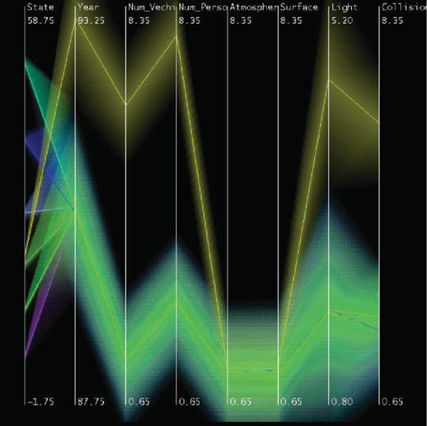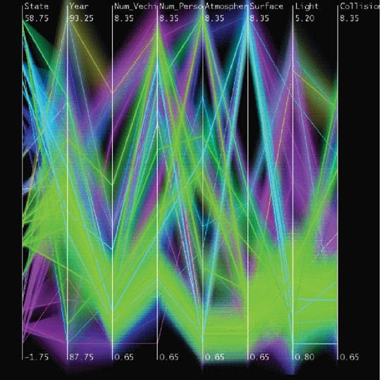

**Figure 26.21.** Hierarchical parallel coordinates show high-dimensional data at multiple levels of detail. *Image courtesy Matt Ward* (Fua et al., 1999), © 1999 IEEE.

* + 1. Graphs



**Figure 26.22.** Graph lay- out aesthetic criteria. Top: Edge crossings should be min- imized. Middle: Angular res- olution should be maximized. Bottom: Symmetry is max- imized on the left, whereas crossings are minimized on the right, showing the conflict between the individually NP- hard criteria.

The field of graph drawing is concerned with finding a spatial position for the nodes in a graph in 2D or 3D space and routing the edges between these nodes (Di Battista, Eades, Tamassia, & Tollis, 1999). In many cases the edge-routing problem is simplified by using only straight edges, or by only allowing right- angle bends for the class of *orthogonal* layouts, but some approaches handle true curves. If the graph has directed edges, a layered approach can be used to show hierarchical structure through the horizontal or vertical spatial ordering of nodes, as shown in Figure 26.2.

A suite of aesthetic criteria operationalize human judgments about readable graphs as metrics that can be computed on a proposed layout (Ware, Purchase, Colpys, & McGill, 2002). Figure 26.22 shows some examples. Some metrics should be minimized, such as the number of edge crossings, the total area of the layout, and the number of right-angle bends or curves. Others should be maximized, such as the angular resolution or symmetry. The problem is difficult because most of these criteria are individually NP-hard, and moreover they are mutually incompatible (Brandenburg, 1988).

Many approaches to node-link graph drawing use force-directed placement, motivated by the intuitive physical metaphor of spring forces at the edges draw- ing together repelling particles at the nodes. Although naive approaches have high time complexity and are prone to being caught in local minima, much work has gone into developing more sophisticated algorithms such as GEM (Frick, Lud- wig, & Mehldau, 1994) or IPSep-CoLa (Dwyer, Koren, & Marriott, 2006). Fig- ure 26.23 shows an interactive system using the *r*-PolyLog energy model, where

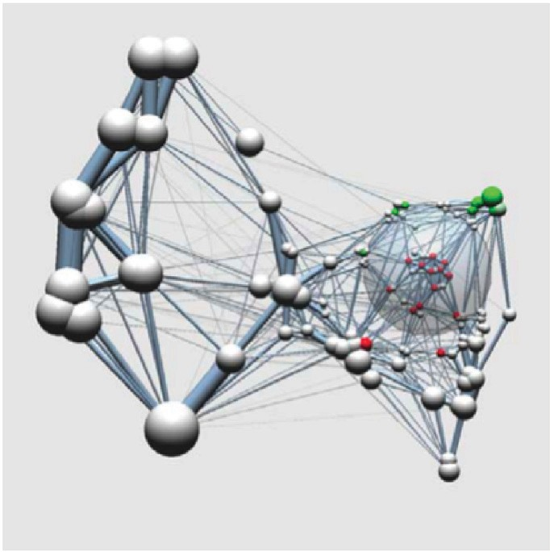

**Figure 26.23.** Force-directed placement showing a clustered graph with both geometric and seman- tic fisheye. *Image courtesy Jarke van Wijk* (van Ham & van Wijk, 2004), © 2004 IEEE.

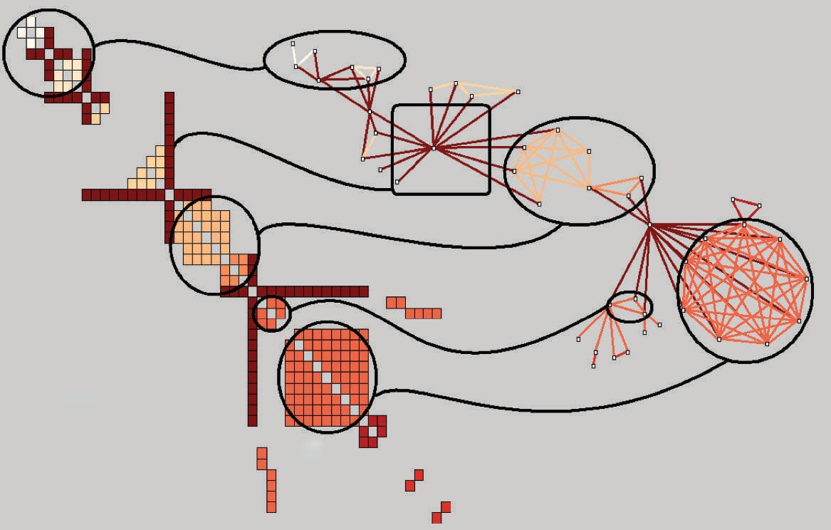

Node-Link

A

B

Matrix

C

**Figure 26.24.** Graphs can be shown with either matrix or node-link views. *Image courtesy Jean- Daniel Fekete* (Henry & Fekete, 2006), © 2006 IEEE.

a focus+context view of the clustered graph is created with both geometric and semantic fisheye (van Ham & van Wijk, 2004).

Graphs can also be visually encoded by showing the adjacency matrix, where all vertices are placed along each axis and the cell between two vertices is colored if there is an edge between them. The MatrixExplorer system uses linked multi- ple views to help social science researchers visually analyze social networks with both matrix and node-link representations (Henry & Fekete, 2006). Figure 26.24 shows the different visual patterns created by the same graph structure in these two views: A represents an actor connecting several communities; B is a com- munity; and C is a clique, or a complete sub-graph. Matrix views do not suffer from cluttered edge crossings, but many tasks including path following are more difficult with this approach.

* + 1. Trees

Trees are a special case of graphs so common that a great deal of visualization research has been devoted to them. A straightforward algorithm to lay out trees in the two-dimensional plane works well for small trees (Reingold & Tilford, 1981), while a more complex but scalable approach runs in linear time (Buchheim, Ju¨ nger, & Leipert, 2002). Figures 26.17 and 26.18 also show trees with different ap- proaches to spatial layout, but all four of these methods visually encode the rela- tionship between parent and child nodes by drawing a link connecting them.

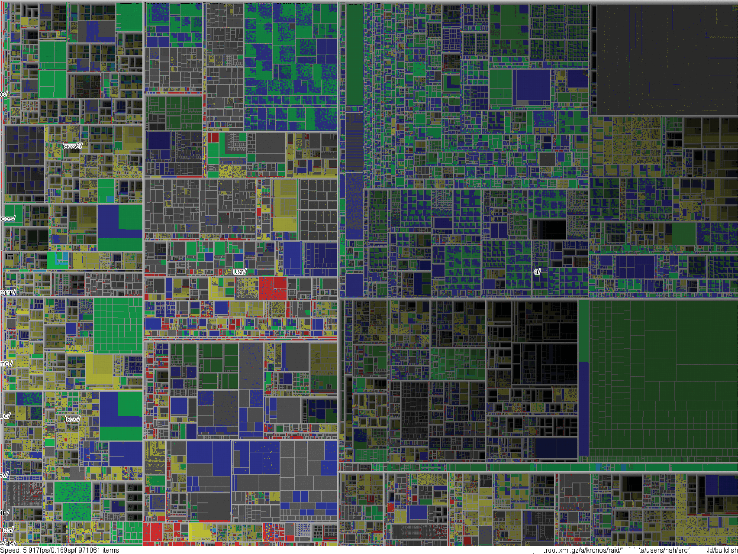

**Figure 26.25.** Treemap showing a filesystem of nearly one million files. *Image courtesy Jean- Daniel Fekete* (Fekete & Plaisant, 2002), © 2002 IEEE.

Treemaps use containment rather than connection to show the hierarchical relationship between parent and child nodes in a tree (B. Johnson & Shneider- man, 1991). That is, treemaps show child nodes nested within the outlines of the parent node. Figure 26.25 shows a hierarchical filesystem of nearly one mil- lion files, where file size is encoded by rectangle size and file type is encoded by color (Fekete & Plaisant, 2002). The size of nodes at the leaves of the tree can encode an additional data dimension, but the size of nodes in the interior does not show the value of that dimension; it is dictated by the cumulative size of their de- scendants. Although tasks such as understanding the topological structure of the tree or tracing paths through it are more difficult with treemaps than with node- link approaches, tasks that involve understanding an attribute tied to leaf nodes are well supported. Treemaps are space-filling representations that are usually more compact than node-link approaches.

* + 1. Geographic

Many kinds of analysis such as epidemiology require understanding both geo- graphic and nonspatial data. Figure 26.26 shows a tool for the visual analysis of a cancer demographics dataset that combines many of the ideas described in this chapter (MacEachren, Dai, Hardisty, Guo, & Lengerich, 2003). The top ma- trix of linked views features small multiples of three types of visual encodings: geographic maps showing Appalachian counties at the lower left, histograms across the diagonal of the matrix, and scatterplots on the upper right. The bot- tom 2 *×* 2 matrix, linking scatterplots with maps, includes the color legend for both. The discrete bivariate sequential colormap has lightness increasing sequen- tially for each of two complementary hues and is effective for color-deficient people.

* + 1. Spatial Fields

Most nongeographic spatial data is modeled as a field, where there are one or more values associated with each point in 2D or 3D space. Scalar fields, for example CT or MRI medical imaging scans, are usually visualized by finding isosurfaces or using direct volume rendering. Vector fields, for example, flows in water or air, are often visualized using arrows, streamlines (McLouglin, Laramee, Peikert, Post, & Chen, 2009), and *line integral convolution* (LIC) (Laramee et al., 2004). Tensor fields, such as those describing the anisotropic diffusion of molecules through the human brain, are particularly challenging to display (Kindlmann, Weinstein, & Hart, 2000).

# Frequently Asked Questions

What conferences and journals are good places to look for further infor- mation about visualization?

*•*

The IEEE VisWeek conference comprises three subconferences: InfoVis (Infor- mation Visualization), Vis (Visualization), and VAST (Visual Analytics Science and Technology). There is also a European EuroVis conference and an Asian PacificVis venue. Relevant journals include IEEE TVCG (Transactions on Visu- alization and Computer Graphics) and Palgrave Information Visualization.

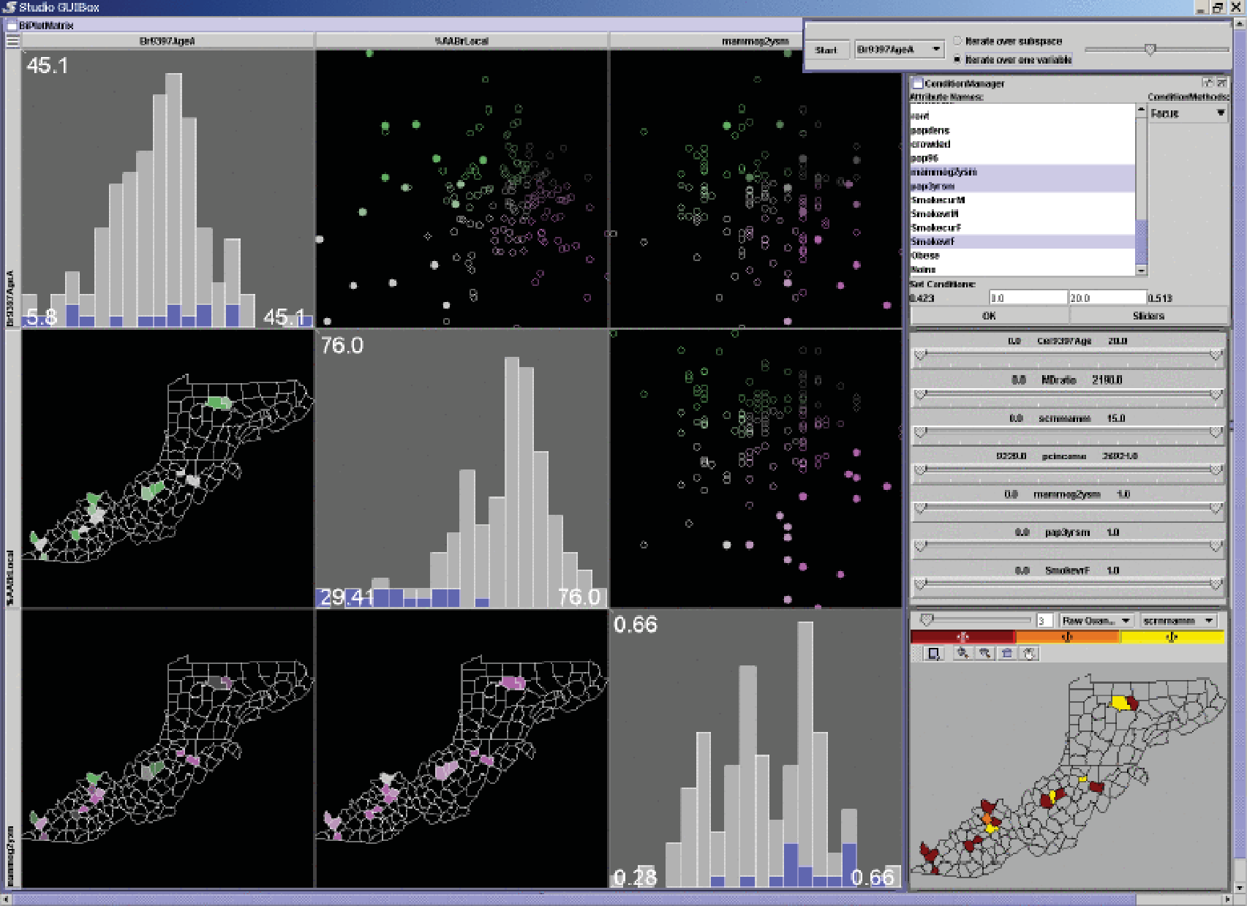

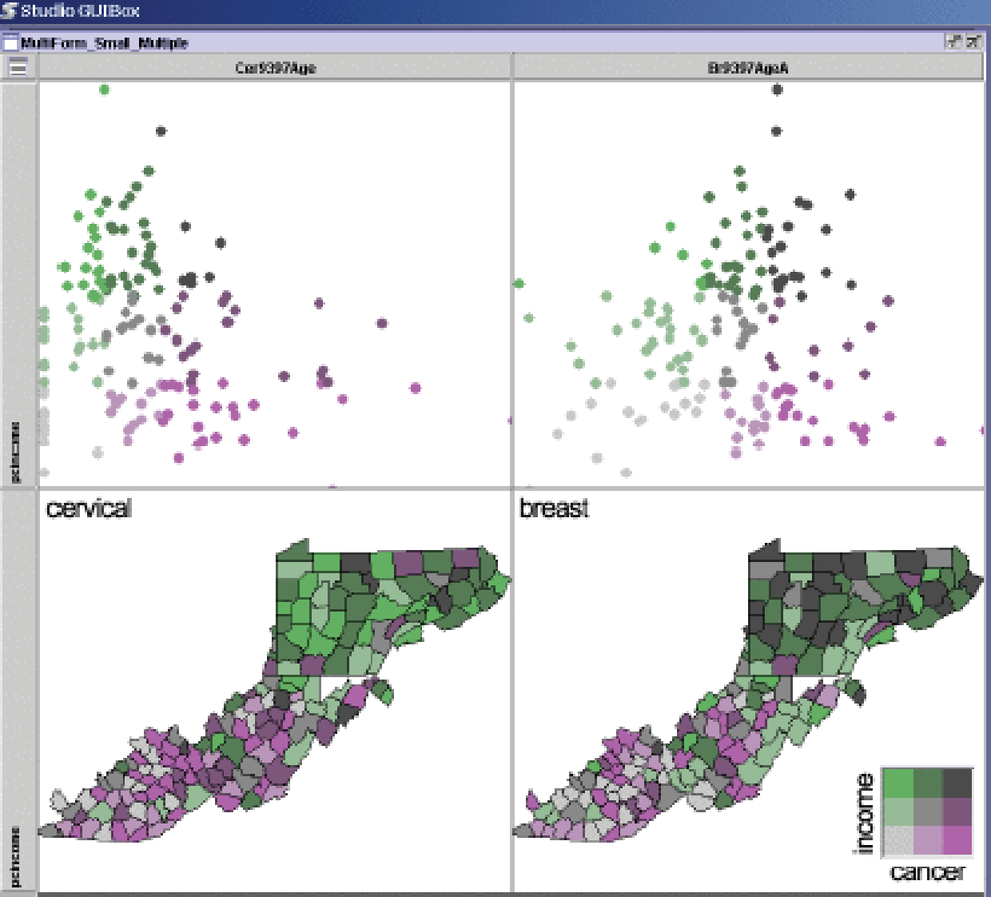

**Figure 26.26.** Two matrices of linked small multiples showing cancer demographic data (MacEachren et al., 2003), © 2003 IEEE.

* What software and toolkits are available for visualization?

The most popular toolkit for spatial data is vtk, a C/C++ codebase available at

[www.vtk.org.](http://www.vtk.org/) For abstract data, the Java-based prefuse ([http://www](http://www/)

.prefuse.org) and Processing (processing.org) toolkits are becoming widely used. The ManyEyes site from IBM Research (www.many-eyes.com) allows people to upload their own data, create interactive visualizations in a vari- ety of formats, and carry on conversations about visual data analysis.

References

Adelson, E. H. (1999). Lightness Perception and Lightness Illusions. In

M. S. Gazzaniga (Ed.), *The New Cognitive Neurosciences* (Second ed., pp. 339–351). Cambridge, MA: MIT Press.

Adzhiev, V., Cartwright, R., Fausett, E., Ossipov, A., Pasko, A., & Savchenko, V. (1999, Sep). Hyperfun Project: A Framework for Collaborative Multidi- mensional F-rep Modeling. In *Implicit Surfaces ’99* (pp. 59–69). Aire-la- ville, Switzerland: Eurographics Association.

Akenine-Mo¨ ller, T., Haines, E., & Hoffman, N. (2008). *Real-Time Rendering*

(Third ed.). Wellesley, MA: A K Peters.

Akkouche, S., & Galin, E. (2001). Adaptive Implicit Surface Polygonization Using Marching Triangles. *Computer Graphics Forum*, *20*(2), 67–80.

Akleman, E., & Chen, J. (1999). Generalized Distance Functions. In *Proceedings of the International Conference on Shape Modeling and Applications* (pp. 72–79). Washington, DC: IEEE Computer Society Press.

Amanatides, J., & Woo, A. (1987). A Fast Voxel Traversal Algorithm for Ray Tracing. In *Proceedings of Eurographics* (pp. 1–10). Amsterdam: Elsevier Science Publishers.

Amar, R., Eagan, J., & Stasko, J. (2005). Low-Level Components of Analytic Activity in Information Visualization. In *Proc. IEEE Symposium on In- formation Visualization (InfoVis)* (pp. 111–117). Washington, DC: IEEE Computer Society Press.

American National Standard Institute. (1986). *Nomenclature and Definitions for Illumination Engineering.* ANSI Report (New York). (ANSI/IES RP-16- 1986)

Angel, E. (2002). *Interactive Computer Graphics: A Top-Down Approach with OpenGL* (Third ed.). Reading, MA: Addison-Wesley.

Appel, A. (1968). Some Techniques for Shading Machine Renderings of Solids. In *Proceedings of the AFIPS Spring Joint Computing Conference* (Vol. 32, pp. 37–45). AFIPS.

Arvo, J. (1995). *Analytic Methods for Simulated Light Transport* (Unpublished doctoral dissertation).

Ashdown, I. (1994). *Radiosity: A Programmer’s Perspective*. New York: John Wiley & Sons.

Ashikhmin, M. (2002). A Tone Mapping Algorithm for High Contrast Images. In

*EGRW ’02: Proceedings of the 13th Eurographics Workshop on Rendering*

701

(pp. 145–155). Aire-la-Ville, Switzerland: Eurographics Association.

Ashikhmin, M., Premozˇe, S., & Shirley, P. (2000). A Microfacet-Based BRDF Generator. In *Proceedings of SIGGRAPH* (pp. 65–74). Reading, MA: Addison-Wesley Longman.

Ashikhmin, M., & Shirley, P. (2000). An Anisotropic Phong BRDF Model.

*journal of graphics tools*, *5*(2), 25–32.

Baerentzen, J., & Christensen, N. (2002, May). Volume Sculpting Using the Level-Set Method. In *SMI ’02: Proceedings of Shape Modeling Interna- tional 2002 (SMI ’02)* (pp. 175–182). Washington, DC: IEEE Computer Society Press.

Barr, A. H. (1984). Global and Local Deformations of Solid Primitives. *Proc.*

*SIGGRAPH ’84 Computer Graphics*, *18*(3), 21–30.

Bartels, R. H., Beatty, J. C., & Barsky, B. A. (1987). *An Introduction to Splines for Use in Computer Graphics and Geometric Modeling*. San Francisco, CA: Morgan Kaufmann.

Barthe, L., Dodgson, N. A., Sabin, M. A., Wyvill, B., & Gaildrat, V. (2003). Two- dimensional Potential Fields for Advanced Implicit Modeling Operators. *Computer Graphics Forum*, *22*(1), 23–33.

Barthe, L., Mora, B., Dodgson, N. A., & Sabin, M. A. (2002). Interactive Implicit Modelling based on C1 Reconstruction of Regular Grids. *International Journal of Shape Modeling*, *8*(2), 99–117.

Baumgart, B. (1974, October). *Geometric Modeling for Computer Vision* (Tech. Rep. No. AIM-249). Palo Alto, CA: Stanford University AI Laboratory.

Beck, K., & Andres, C. (2004). *Extreme Programming Explained: Embrace Change* (Second ed.). Reading, MA: Addison-Wesley.

Berlin, B., & Kay, P. (1969). *Basic Color Terms: Their Universality and Evolu- tion*. Berkeley, CA: University of California Press.

Berns, R. S. (2000). *Billmeyer and Saltzman’s Principles of Color Technology*

(3rd ed.). New York: John Wiley and Sons.

Blinn, J. (1982). A Generalization of Algebraic Surface Drawing. *ACM Trans- actions on Graphics*, *1*(3), 235–258.

Blinn, J. (1996). *Jim Blinn’s Corner*. San Francisco, CA: Morgan Kaufmann. Blinn, J. F. (1976). Texture and Reflection in Computer Generated Images. *Com-*

*munications of the ACM*, *19*(10), 542–547.

Bloomenthal, J. (1988). Polygonization of Implicit Surfaces. *Computer Aided Geometric Design*, *4*(5), 341–355.

Bloomenthal, J. (1990). Calculation of Reference Frames Along a Space Curve. In A. Glassner (Ed.), *Graphics Gems* (pp. 567–571). Boston: Academic Press.

Bloomenthal, J. (1995). *Skeletal Design of Natural Forms* (Unpublished doctoral dissertation). University of Calgary, Canada.

Bloomenthal, J. (1997). Bulge Elimination in Convolution Surfaces. *Computer Graphics Forum*, *16*(1), 31–41.

Bloomenthal, J., & Shoemake, K. (1991). Convolution Surfaces. *Proc. SIG- GRAPGH ’91, Computer Graphics*, *25*(4), 251–257.

Brandenburg, F. J. (1988). Nice Drawing of Graphs are Computationally Hard. In P. Gorney & M. J. Tauber (Eds.), *Visualization in Human-Computer In- teraction* (pp. 1–15). Berlin: Springer-Verlag.

Bresenham, J. E. (1965). Algorithm for Computer Control of a Digital Plotter.

*IBM Systems Journal*, *4*(1), 25–30.

Brewer, C. A. (1999). Color Use Guidelines for Data Representation. In *Proc. Section on Statistical Graphics* (pp. 55–60). Alexandria, VA: American Statistical Association.

Buchheim, C., Ju¨ nger, M., & Leipert, S. (2002). Improving Walker’s Algorithm to Run in Linear Time. In *GD ’02: Revised Papers from the 10th Interna- tional Symposium on Graph Drawing* (pp. 344–353). London: Springer- Verlag.

Campagna, S., Kobbelt, L., & Seidel, H.-P. (1998). Directed Edges—A Scalable Representation for Triangle Meshes. *journal of graphics tools*, *3*(4), 1–12.

Carr, J. C., Beatson, R. K., Cherrie, J. B., Mitchell, T. J., Fright, W. R., McCal- lum, B. C., & Evans, T. R. (2001). Reconstruction and representation of 3d objects with radial basis functions. In *SIGGRAPH ’01: Proceedings of the 28th Annual Conference on Computer Graphics and Interactive Techniques* (pp. 67–76). New York: ACM Press.

Chiu, K., Herf, M., Shirley, P., Swamy, S., Wang, C., & Zimmerman, K. (1993). Spatially Nonuniform Scaling Functions for High Contrast Images. In *Pro- ceedings of Graphics Interface ’93* (pp. 245–253). Wellesley, MA: A K Peters & Canadian Human-Computer Communications Society.

Choudhury, P., & Tumblin, J. (2003). The Trilateral Filter for High Contrast Images and Meshes. In *EGRW ’03: Proceedings of the 14th Eurographics Workshop on Rendering* (pp. 186–196). Aire-la-Ville, Switzerland: Euro- graphics Association.

Cleary, J., Wyvill, B., Birtwistle, G., & Vatti, R. (1983). A Parallel Ray Tracing Computer. In *Proceedings of the Association of Simula Users Conference* (pp. 77–80).

Cohen, E., Riesenfeld, R. F., & Elber, G. (2001). *Geometric Modeling with Splines: An Introduction*. Wellesley, MA: A K Peters.

Cohen, M. F., Chen, S. E., Wallace, J. R., & Greenberg, D. P. (1988). A Progres- sive Refinement Approach to Fast Radiosity Image Generation. In *SIG- GRAPH ’88: Proceedings of the 15th Annual Conference on Computer Graphics and Interactive Techniques* (pp. 75–84). New York: ACM Press. Cohen, M. F., & Wallace, J. R. (1993). *Radiosity and Realistic Image Synthesis*.

Cambridge, MA: Academic Press, Inc.

Comaniciu, D., & Meer, P. (2002). Mean Shift: A Robust Approach Toward Fea- ture Space Analysis. *IEEE Transactions on Pattern Analysis and Machine Intelligence*, *24*(5), 603–619.

Cook, R. L., Carpenter, L., & Catmull, E. (1987). The Reyes Image Rendering Architecture. *Proc. SIGGRAPH ’87 Computer Graphics*, *21*(4), 95–102.

Cook, R. L., Porter, T., & Carpenter, L. (1984). Distributed Ray Tracing. *Proc.*

*SIGGRAPH ’84, Computer Graphics*, *18*(3), 137–145.

Cook, R. L., & Torrance, K. E. (1982). A Reflectance Model for Computer Graphics. *ACM Transactions on Graphics*, *1*(1), 7–24.

Crow, F. C. (1978). The Use of Grayscale for Improved Raster Display of Vectors and Characters. In *SIGGRAPH ’78: Proceedings of the 5th Annual Con- ference on Computer Graphics and Interactive Techniques* (pp. 1–5). New York: ACM Press.

Crowe, M. J. (1994). *A History of Vector Analysis*. Mineola, NY: Dover.

da Vinci, L. (1970). *The Notebooks of Leonardo da Vinci* (Vol. 1). Mineola, NY: Dover Press.

Dachsbacher, C., Vogelgsang, C., & Stamminger, M. (2003). Sequential Point Trees. *ACM Transactions on Graphics, (Proc. SIGGRAPH 03)*, *22*(3), 657– 662.

Debevec, P. E., & Malik, J. (1997). Recovering High Dynamic Range Radi- ance Maps from Photographs. In *SIGGRAPH ’97: Proceedings of the 24th Annual Conference on Computer Graphics and Interactive Techniques* (pp. 369–378). Reading, MA: Addison-Wesley.

De Boor, C. (1978). *A Practical Guide to Splines*. Berlin: Springer-Verlag. De Boor, C. (2001). *A Practical Guide to Splines*. Berlin: Springer-Verlag.

deGroot, E., & Wyvill, B. (2005). Rayskip: Faster Ray Tracing of Implicit Sur- face Animations. In *GRAPHITE ’05: Proceedings of the 3rd International Conference on Computer Graphics and Interactive Techniques in Australa- sia and South East Asia* (pp. 31–36). New York: ACM Press.

DeRose, T. (1989). *A Coordinate-Free Approach to Geometric Programming*

(Tech. Rep. No. 89-09-16). Seattle, WA: University of Washington.

Di Battista, G., Eades, P., Tamassia, R., & Tollis, I. G. (1999). *Graph Drawing: Algorithms for the Visualization of Graphs*. Englewood Cliffs, NJ: Prentice Hall.

Dinh, H., Slabaugh, G., & Turk, G. (2001). Reconstructing Surfaces Using Anisotropic Basis Functions. In *International Conference on Computer Vision (ICCV) 2001* (pp. 606–613). Washington, DC: IEEE.

Dobkin, D. P., & Mitchell, D. P. (1993). Random-Edge Discrepancy of Su- persampling Patterns. In *Proceedings of Graphics Interface* (pp. 62–69). Wellesley, MA: A K Peters & Canadian Human-Computer Communica- tions Society.

Dooley, D., & Cohen, M. F. (1990). Automatic Illustration of 3D Geometric Mod- els: Lines. In *SI3D ’90: Proceedings of the 1990 Symposium on Interactive 3D Graphics* (pp. 77–82). New York: ACM Press.

Doran, C., & Lasenby, A. (2003). *Geometric Algebra for Physicists*. Cambridge, UK: Cambridge University Press.

Drago, F., Myszkowski, K., Annen, T., & Chiba, N. (2003). Adaptive Logarithmic Mapping for Displaying High Contrast Scenes. *Computer Graphics Forum*, *22*(3), 419–426.

Duchon, J. (1977). Constructive Theory of Functions of Several Variables. In (pp. 85–100). Berlin: Springer-Verlag.

Durand, F., & Dorsey, J. (2002). Fast Bilateral Filtering for the Display of High- Dynamic-Range Images. *ACM Transactions on Graphics*, *21*(3), 257–266.

Dutre´, P., Bala, K., & Bekaert, P. (2002). *Advanced Global Illumination*. Welles- ley, MA: A K Peters.

Dwyer, T., Koren, Y., & Marriott, K. (2006). IPSep-CoLa: An Incremental Proce- dure for Separation Constraint Layout of Graphs. *IEEE Trans. Visualization and Computer Graphics (Proc. InfoVis 06)*, *12*(5), 821–828.

Eberly, D. (2000). *3D Game Engine Design: A Practical Approach to Real-Time Computer Graphics*. San Francisco, CA: Morgan Kaufmann.

Eckman, P., & Friesen, W. V. (1978). *Facial Action Coding System*. Palo Alto, CA: Consulting Psychologists Press.

Eick, S. G., Steffen, J. L., & Sumner, E. E., Jr. (1992). Seesoft-A Tool for Visualizing Line Oriented Software Statistics. *IEEE Trans. Software Eng.*, *18*(11), 957–968.

Ershov, S., Kolchin, K., & Myszkowski, K. (2001). Rendering Pearlescent Ap- pearance Based on Paint-Composition Modelling. *Computer Graphics Fo- rum*, *20*(3), 227–238.

Fairchild, M. D. (2005). *Color Appearance Models* (Second ed.). New York: John Wiley & Sons.

Fairchild, M. D., & Johnson, G. M. (2002). Meet iCAM: An Image Color Ap- pearance Model. In *IS&T/SID 10th Color Imaging Conference* (pp. 33–38). Springfield, VA: Society for Imaging Science & Technology.

Fairchild, M. D., & Johnson, G. M. (2004). The iCAM Framework for Image Appearance, Image Differences, and Image Quality. *Journal of Electronic Imaging*, *13*, 126–138.

Farin, G. (2002). *Curves and Surfaces for CAGD: A Practical Guide*. San Francisco, CA: Morgan Kaufmann.

Farin, G., & Hansford, D. (2004). *Practical Linear Algebra: A Geometry Tool- box*. Wellesley, MA: A K Peters.

Farin, G., Hoschek, J., & Kim, M.-S. (Eds.). (2002). *Handbook of Computer Aided Geometric Design*. Amsterdam: Elsevier.

Fattal, R., Lischinski, D., & Werman, M. (2002). Gradient Domain High Dynamic Range Compression. *ACM Transactions on Graphics*, *21*(3), 249–256.

Fekete, J.-D., & Plaisant, C. (2002). Interactive Information Visualization of a Million Items. In *Proc. IEEE Symposium on Information Visualization (In- foVis 02)* (pp. 117–124). Washington, DC: IEEE Computer Society Press.

Ferwerda, J. A., Pattanaik, S., Shirley, P., & Greenberg, D. P. (1996). A Model of Visual Adaptation for Realistic Image Synthesis. In *SIGGRAPH ’96:*

*Proceedings of the 23rd Annual Conference on Computer Graphics and Interactive Techniques* (pp. 249–258). New York: ACM Press.

Ferwerda, J. A., Shirley, P., Pattanaik, S. N., & Greenberg, D. P. (1997). A Model of Visual Masking for Computer Graphics. In *SIGGRAPH ’97: Proceedings of the 24th Annual Conference on Computer Graphics and Interactive Techniques* (pp. 143–152). Reading, MA: Addison-Wesley.

Foley, J. D., Van Dam, A., Feiner, S. K., & Hughes, J. F. (1990). *Computer Graphics: Principles and Practice* (Second ed.). Reading, MA: Addison- Wesley.

Forsyth, D. A., & Ponce, J. (2002). *Computer Vision: A Modern Approach*.

Englewoods Cliffs, NJ: Prentice Hall.

Francis S. Hill, J. (2000). *Computer Graphics Using OpenGL* (Second ed.).

Englewood Cliffs, NJ: Prentice Hall.

Frick, A., Ludwig, A., & Mehldau, H. (1994). A Fast Adaptive Layout Algorithm for Undirected Graphs. In *GD ’94: Proceedings of the DIMACS Interna- tional Workshop on Graph Drawing* (pp. 388–403). London: Springer- Verlag.

Friendly, M. (2008). A Brief History of Data Visualization. In *Handbook of Data Visualization* (pp. 15–56). (Web document,<http://www.math.yorku.ca/SCS/Gallery/milestone/.)>

Frisken, S., Perry, R., Rockwood, A., & Jones, T. (2000). Adaptively Sampled Distance Fields. In *Siggraph ’00: Proceedings of the 27th Annual Con- ference on Computer Graphics and Interactive Techniques* (pp. 249–254). New York: ACM Press/Addison-Wesley Publishing Co.

Fua, Y.-H., Ward, M. O., & Rundensteiner, E. A. (1999). Hierarchical Parallel Coordinates for Exploration of Large Datasets. In *Proc. IEEE Visualiza- tion Conference (Vis ’99)* (pp. 43–50). Washington, DC: IEEE Computer Society Press.

Fujimoto, A., Tanaka, T., & Iwata, K. (1986). ARTSccelerated Ray-Tracing System. *IEEE Computer Graphics & Applications*, *6*(4), 16–26.

Galin, E., & Akkouche, S. (1999). Incremental Polygonization of Implicit Sur- faces. *Graphical Models*, *62*(1), 19–39.

Gansner, E. R., Koutsofois, E., North, S. C., & Vo, K.-P. (1993, March). A Technique for Drawing Directed Graphs. *IEEE Transactions on Software Engineering*, *19*(3), 214–229.

Gascuel, M.-P. (1993, Aug). An Implicit Formulation for Precise Contact Model- ing Between Flexible Solids. In *SIGGRAPH ’93: Proceedings of the 20th Annual Conference on Computer Graphics and Interactive Techniques* (pp. 313–320). New York: ACM Press.

Gibson, J. J. (1950). *The Perception of the Visual World*. Cambridge, MA: Riverside Press.

Gilchrist, A. L., Kossyfidis, C., Bonato, F., Agostini, T., Cataliotti, J., Li, X.,

. . . Economou, E. (1999). An Anchoring Theory of Lightness Perception.

*Psychological Review*, *106*(4), 795–834.

Glassner, A. (1984). Space Subdivision for Fast Ray Tracing. *IEEE Computer Graphics & Applications*, *4*(10), 15–22.

Glassner, A. (1988). Spacetime Ray Tracing for Animation. *IEEE Computer Graphics & Applications*, *8*(2), 60–70.

Glassner, A. (Ed.). (1989). *An Introduction to Ray Tracing*. London: Academic Press.

Glassner, A. (1995). *Principles of Digital Image Synthesis*. San Francisco, CA: Morgan Kaufmann.

Goldman, R. (1985). Illicit Expressions in Vector Algebra. *ACM Transactions on Graphics*, *4*(3), 223–243.

Goldsmith, J., & Salmon, J. (1987). Automatic Creation of Object Hierarchies for Ray Tracing. *IEEE Computer Graphics & Applications*, *7*(5), 14–20.

Gooch, A., Gooch, B., Shirley, P., & Cohen, E. (1998). A Non-Photorealistic Lighting Model for Automatic Technical Illustration. In *SIGGRAPH ’98: Proceedings of the 25th Annual Conference on Computer Graphics and Interactive Techniques* (pp. 447–452). New York: ACM Press.

Goral, C. M., Torrance, K. E., Greenberg, D. P., & Battaile, B. (1984). Modeling the Interaction of Light between Diffuse Surfaces. *Proc. SIGGRAPH ’84, Computer Graphics*, *18*(3), 213–222.

Gouraud, H. (1971). Continuous Shading of Curved Surfaces. *Communications of the ACM*, *18*(6), 623–629.

Grassmann, H. (1853). Zur Theorie der Farbenmischung. *Annalen der Physik und Chemie*, *89*, 69–84.

Gregory, R. L. (1997). *Eye and Brain: The Psychology of Seeing* (Fifth ed.).

Princeton, NJ: Princeton University Press.

Grosjean, J., Plaisant, C., & Bederson, B. (2002). SpaceTree: Supporting Explo- ration in Large Node Link Tree, Design Evolution and Empirical Evalua- tion. In *Proc. IEEE Symposium on Information Visualization (InfoVis)* (pp. 57–64). Washington, DC: IEEE Computer Society Press.

Grossman, T., Wigdor, D., & Balakrishnan, R. (2007). Exploring and Reducing the Effects of Orientation on Text Readability in Volumetric Displays. In *Proc. ACM Conf. Human Factors in Computing Systems (CHI)* (pp. 483– 492). New York: ACM Press.

Hammersley, J., & Handscomb, D. (1964). *Monte-Carlo Methods*. London: Methuen.

Hanrahan, P., & Lawson, J. (1990). A Language for Shading and Lighting Calcu- lations. In *SIGGRAPH ’90: Proceedings of the 17th Annual Conference on Computer Graphics and Interactive Techniques* (pp. 289–298). New York: ACM Press.

Hanson, A. J. (2005). *Visualizing Quaternions*. San Francisco, CA: Morgan Kaufmann.

Harris, M. J. (2004). Fast Fluid Dynamics Simulation on the GPU. In *GPU Gems: Programming Techniques, Tips, and Tricks for Real-Time Graphics* (chap. 38). Reading, MA: Addison-Wesley.

Hart, J. C., & Baker, B. (1996, Oct). Implicit Modeling of Tree Surfaces. In *Pro- ceedings of Implicit Surfaces ’96* (pp. 143–152). Aire-la-Ville, Switzerland: Eurographics Association.

Hartmann, E. (1998). A Marching Method for the Triangulation of Surfaces. *The Visual Computer*, *14*(3), 95–108.

Hausner, M. (1998). *A Vector Space Approach to Geometry*. Mineola, NY: Dover.

Havran, V. (2000). *Heuristic Ray Shooting Algorithms* (Unpublished doctoral dissertation). Czech Technical University in Prague.

He, X. D., Heynen, P. O., Phillips, R. L., Torrance, K. E., Salesin, D. H., & Greenberg, D. P. (1992). A Fast and Accurate Light Reflection Model. *Proc. SIGGRAPH ’92, Computer Graphics*, *26*(2), 253–254.

Hearn, D., & Baker, M. P. (1986). *Computer Graphics*. Englewood Cliffs, N.J.: Prentice Hall.

Heer, J., & Robertson, G. (2007). Animated Transitions in Statistical Data Graph- ics. *IEEE Trans. on Visualization and Computer Graphics (Proc. Info- Vis07)*, *13*(6), 1240–1247.

Heidrich, W., & Seidel, H.-P. (1998). Ray-Tracing Procedural Displacement Shaders. In *Proceedings of Graphics Interface* (pp. 8–16). Wellesley, MA: A K Peters & Canadian Human-Computer Communications Society.

Henry, N., & Fekete, J.-D. (2006). MatrixExplorer: a Dual-Representation Sys- tem to Explore Social Networks. *IEEE Trans. Visualization and Computer Graphics (Proc. InfoVis 06)*, *12*(5), 677–684.

Hoffmann, B. (1975). *About Vectors*. Mineola, NY: Dover.

Hofstadter, D. (1979). *Go¨ del, Escher, Bach: an Eternal Golden Braid*. New York: Basic Books.

Hood, D. C., Finkelstein, M. A., & Buckingham, E. (1979). Psychophysical Tests of Models of the Response Function. *Vision Research*, *19*, 401–406.

Hoppe, H. (1994). *Surface Reconstruction from Unorganized Points* (Unpub- lished doctoral dissertation). University of Washington.

Horn, B. K. P. (1974). Determining Lightness from an Image. *CVGIP*, *3*, 277– 299.

Hughes, J. F., & Mo¨ ller, T. (1999). Building an Orthonormal Basis from a Unit Vector. *journal of graphics tools*, *4*(4), 33–35.

Hunt, R. W. G. (2004). *The Reproduction of Color* (6th ed.). Chichester, UK: John Wiley and Sons.

IEEE Standards Association. (1985). *IEEE Standard for Binary Floating-Point Arithmetic* (Tech. Rep.). New York: IEEE Report. (ANSI/IEEE Std 754- 1985)

Igarashi, T., Matsuoka, S., & Tanaka, H. (1999). Teddy: A Sketching Interface for 3D Freeform Design. In *Siggraph ’99: Proceedings of the 26th Annual Conference on Computer Graphics and Interactive Techniques* (pp. 409– 416). New York: ACM Press/Addison-Wesley Publishing Co.

Immel, D. S., Cohen, M. F., & Greenberg, D. P. (1986). A Radiosity Method for Non-Diffuse Environments. *Proc. SIGGRAPH ’86, Computer Graphics*, *20*(4), 133–142.

Ingram, S., Munzner, T., & Olano, M. (2009). Glimmer: Multilevel MDS on the GPU. *IEEE Trans. Visualization and Computer Graphics*, *15*(2), 249–261. Inselberg, A., & Dimsdale, B. (1990). Parallel Coordinates: A Tool for Visu- alizing Multi-Dimensional Geometry. In *Vis ’90: Proceedings of the 1st Conference on Visualization ’90.* Los Alamitos, CA: IEEE Computer Soci-

ety Press.

Jansen, F. W. (1986). Data Structures for Ray Tracing. In *Proceedings of a Workshop Eurographics Seminars on Data Structures for Raster Graphics* (pp. 57–73). New York: Springer-Verlag.

Jensen, H. W. (2001). *Realistic Image Synthesis Using Photon Mapping*. Welles- ley, MA: A K Peters.

Johansson, G. (1973). Visual Perception of Biological Motion and a Model for Its Analysis. *Perception & Psychophysics*, *14*, 201–211.

Johnson, B., & Shneiderman, B. (1991). Treemaps: A Space-filling Approach to the Visualization of Hierarchical Information. In *VIS ’91: Proceedings of the 2nd Conference on Visualization ’91* (pp. 284–291). Los Alamitos, CA: IEEE Computer Society Press.

Johnson, G. M., & Fairchild, M. D. (2003). Rendering HDR Images. In *IS&T/SID 11th Color Imaging Conference* (pp. 36–41). Springfield, VA: Society for Imaging Science & Technology.

Jones, J. A., Harrold, M. J., & Stasko, J. (2002). Visualization of Test Information to Assist Fault Localization. In *ICSE ’02: Proceedings of the 24th Inter- national Conference on Software Engineering* (pp. 467–477). New York: ACM Press.

Judd, D. B. (1932). Chromaticity Sensibility to Stimulus Differences. *Journal of the Optical Society of America*, *22*, 72–108.

Kainz, F., Bogart, R., & Hess, D. (2003). The OpenEXR Image File Format. In *SIGGRAPH Technical Sketches.* New York: ACM Press. (see also: <http://www.openexr.com/)>

Kajiya, J. T. (1986). The Rendering Equation. *Proc SIGGRAPH ’86 Computer Graphics*, *20*(4), 143–150.

Kalos, M., & Whitlock, P. (1986). *Monte Carlo Methods, Basics*. New York: Wiley-Interscience.

Kalra, D., & Barr, A. (1989, July). Guaranteed Ray Intersections with Implicit Functions. *Computer Graphics (Proc. SIGGRAPH 89)*, *23*(3), 297–306.

Kay, D. S., & Greenberg, D. (1979). Transparency for Computer Synthesized Images. *Proc. SIGGRAPH ’79 Computer Graphics*, *13*(2), 158–164.

Kernighan, B. W., & Pike, R. (1999). *The Practice of Programming*. Reading, MA: Addison-Wesley.

Kersten, D., Mamassian, P., & Knill, D. C. (1997). Moving Cast Shadows Induce Apparent Motion in Depth. *Perception*, *26*(2), 171–192.

Kindlmann, G., Weinstein, D., & Hart, D. (2000). Strategies for Direct Volume Rendering of Diffusion Tensor Fields. *IEEE Transactions on Visualization and Computer Graphics*, *6*(2), 124–138.

Kirk, D., & Arvo, J. (1988). The Ray Tracing Kernel. In *Proceedings of Aus- graph.* Melbourne, Australia: Australian Computer Graphics Association. Klatzky, R. L. (1998). Allocentric and Egocentric Spatial Representations: Def- initions, Distinctions, and Interconnections. In C. Freksa, C. Habel, &

K. F. Wender (Eds.), *Spatial Cognition—An Interdisciplinary Approach to Representation and Processing of Spatial Knowledge* (Vol. 5, pp. 1–17). Berlin: Springer-Verlag.

Knill, D. C. (1998). Surface Orientation From Texture: Ideal Observers, Generic Observers and the Information Content of Texture Cues. *Vision Research*, *38*, 1655–1682.

Kollig, T., & Keller, A. (2002). Efficient Multidimensional Sampling. *Computer Graphics Forum*, *21*(3), 557–564.

Kovitz, B. L. (1999). *Practical Sofware Requirements: A Manual of Content & Style*. New York: Manning.

Lafortune, E. P. F., Foo, S.-C., Torrance, K. E., & Greenberg, D. P. (1997). Non-Linear Approximation of Reflectance Functions. In *Proceedings of SIGGRAPH ’97* (pp. 117–126). Reading, MA: Addison-Wesley.

Laramee, R. S., Hauser, H., Doleisch, H., Vrolijk, B., Post, F. H., & Weiskopf,

D. (2004). The State of the Art in Flow Visualization: Dense and Texture- Based Techniques. *Computer Graphics Forum*, *23*(2), 203–221.

Lasseter, J. (1987). Principles of Traditional Animation Applied to 3D Computer Animation. *Proc. SIGGRAPH ’87, Computer Graphics*, *21*(4), 35–44.

Lawrence, J., Rusinkiewicz, S., & Ramamoorthi, R. (2004). Efficient BRDF Importance Sampling Using a Factored Representation. *ACM Transactions on Graphics (Proc. SIGGRAPH ’04)*, *23*(3), 496–505.

Lee, D. N., & Reddish, P. (1981). Plummeting Gannets: A Paradigm of Ecologi- cal Optics. *Nature*, *293*, 293–294.

Leung, T., & Malik, J. (1997). On Perpendicular Texture: Why Do We See More Flowers in the Distance? In *Proc. IEEE Conference on Computer Vision and Pattern Recognition* (pp. 807–813). Los Alamitos, CA: IEEE Press.

Lewis, C., & Rieman, J. (1993). *Task-Centered User Interface Design: A Practi- cal Introduction.* [http://hcibib.org/tcuid/.](http://hcibib.org/tcuid/)

Lewis, R. R. (1994). Making Shaders More Physically Plausible. *Computer Graphics Forum*, *13*(2), 109–120.

Loop, C. (2000). *Managing Adjacency in Triangular Meshes* (Tech. Rep. No.

MSR-TR-2000-24). Bellingham, WA: Microsoft Research.

Lorensen, W., & Cline, H. (1987). Marching Cubes: A High Resolution 3D Surface Construction Algorithm. *Computer Graphics (Proc. SIGGRAPH 87)*, *21*(4), 163–169.

Luboschik, M., Schumann, H., & Cords, H. (2008). Particle-Based Labeling: Fast Point-Feature Labeling without Obscuring Other Visual Features. *IEEE Trans. on Visualization and Computer Graphics (Proc. InfoVis08)*, *14*(6), 1237–1244.

MacEachren, A., Dai, X., Hardisty, F., Guo, D., & Lengerich, G. (2003). Ex- ploring High-D Spaces with Multiform Matrices and Small Multiples. In *Proc. IEEE Symposium on Information Visualization (InfoVis)* (pp. 31–38). Washington, DC: IEEE Computer Society Press.

Mackinlay, J. (1986). Automating the Design of Graphical Presentations of Re- lational Information. *ACM Trans. on Graphics (TOG)*, *5*(2), 110–141.

Malley, T. (1988). *A Shading Method for Computer Generated Images* (Unpub- lished master’s thesis). Computer Science Department, University of Utah. Marschner, S. R., & Lobb, R. J. (1994, Oct). An Evaluation of Reconstruction Fil- ters for Volume Rendering. In *VIS ’94: Proceedings of the Conference on Visualization ’94* (pp. 100–107). Washington, DC: IEEE Computer Society

Press.

Marshall, J. A., Burbeck, C. A., Arely, D., Rolland, J. P., & Martin, K. E. (1999). Occlusion Edge Blur: A Cue to Relative Visual Depth. *Journal of the Optical Society of America A*, *13*, 681–688.

Matusik, W., Pfister, H., Brand, M., & McMillan, L. (2003). A Data-Driven Reflectance Model. *ACM Transactions on Graphics (Proc. SIGGRAPH ’03)*, *22*(3), 759–769.

McLouglin, T., Laramee, R. S., Peikert, R., Post, F. H., & Chen, M. (2009). Over Two Decades of Integration-Based Geometric Flow Visualization. In *Proc. Eurographics 2009, State of the Art Reports.* Aire-la-Ville, Switzerland: Eurographics Association.

Meyers, S. (1995). *More Effective C++: 35 New Ways to Improve Your Programs and Designs*. Reading, MA: Addison-Wesley.

Meyers, S. (1997). *Effective C++: 50 Specific Ways to Improve Your Programs and Designs* (Second ed.). Reading, MA: Addison-Wesley.

Mitchell, D. P. (1990, May). Robust Ray Intersection with Interval Arithmetic. In *Graphics interface ’90* (pp. 68–74). Wellesley, MA: Canadian Human- Computer Communications Society & A K Peters.

Mitchell, D. P. (1996). Consequences of Stratified Sampling in Graphics. In *SIGGRAPH ’96: Proceedings of the 23rd Annual Conference on Computer Graphics and Interactive Techniques* (pp. 277–280). New York: ACM Press.

Mitchell, D. P., & Netravali, A. N. (1988). Reconstruction Filters in Computer Graphics. *Computer Graphics*, *22*(4), 221–228.

Morse, B., Yoo, T., Rheingans, P., Chen, D., & Subramanian, K. (2001). Inter- polating Implicit Surfaces from Scattered Surface Data Using Compactly Supported Radial Basis Functions. In *Proceedings of Shape Modeling In- ternational* (pp. 89–98). Washington, DC: IEEE Computer Society Press.

Mortenson, M. (1985). *Geometric Modeling*. New York: John Wiley & Sons. Munkres, J. (2000). *Topology* (Second ed.). Englewood Cliffs, NJ: Prentice Hall.

Munzner, T. (2000). *Interactive Visualization of Large Graphs and Networks* (Unpublished doctoral dissertation). Stanford University Department of Computer Science.

Munzner, T., Guimbretie`re, F., Tasiran, S., Zhang, L., & Zhou, Y. (2003). Tree- Juxtaposer: Scalable Tree Comparison Using Focus+Context with Guaran- teed Visibility. *ACM Transactions on Graphics (Proc. SIGGRAPH ’03)*, *22*(3), 453–462.

Museth, K., Breen, D., Whitaker, R., & Barr, A. (2002). Level Set Surface Editing Operators. *ACM Transactions on Graphics*, *21*(3), 330–338.

Muuss, M. J. (1995). Towards Real-Time Ray-Tracing of Combinatorial Solid Geometric Models. In *Proceedings of BRL-CAD Symposium.*

Nicodemus, F. E., Richmond, J. C., Hsia, J. J., Ginsberg, I., & Limperis, T. (1977). *Geometrical Considerations and Nomenclature for Reflectance* (Tech. Rep. No. 160). Washington, D.C.: National Bureau of Standards.

Nishimura, H., Hirai, A., Kawai, T., Kawata, T., Shirikawa, I., & Omura, K. (1985). Object Modeling by Distribution Function and a Method of Image Generation. In *J. Electronics Comm. Conf. ’85* (Vol. J69-D, pp. 718–725). Ohtake, Y., Belyaev, A., & Pasko, A. (2003). Dynamic Mesh Optimization for Polygonized Implicit Surfaces with Sharp Features. *The Visual Computer*,

*19*(2), 115–126.

Oppenheim, A. V., Schafer, R., & Stockham, T. (1968). Nonlinear Filtering of Multiplied and Convolved Signals. *Proceedings of the IEEE*, *56*(8), 1264– 1291.

Oren, M., & Nayar, S. K. (1994). Generalization of Lambert’s Reflectance Model. In *SIGGRAPH ’94: Proceedings of the 21st Annual Conference on Computer Graphics and Interactive Techniques* (pp. 239–246). New York: ACM Press.

Osher, S., & Sethian, J. A. (1988). Fronts Propagating with Curvature-Dependent Speed: Algorithms Based on Hamilton–Jacobi Formulations. *Journal of Computational Physics*, *79*(1), 12–49.

Osterberg, G. (1935). Topography of the Layer of Rods and Cones in the Human Retina. *Acta Ophthalmologica*, *6*(1), 11–97. (Supplement)

Paeth, A. W. (1990). A Fast Algorithm for General Raster Rotation. In *Graphics Gems* (pp. 179–195). Boston, MA: Academic Press.

Palmer, S. E. (1999). *Vision Science—Photons to Phenomenology*. Cambridge, MA: MIT Press.

Parker, S., Martin, W., Sloan, P., Shirley, P., Smits, B., & Hansen, C. (1999). Interactive Ray Tracing. In *ACM Symposium on Interactive 3D Graphics* (pp. 119–126). New York: ACM Press.

Parker, S. G., Bigler, J., Dietrich, A., Friedrich, H., Hoberock, J., Luebke, D., . . . Stich, M. (2010, July). Optix: A General Purpose Ray Tracing Engine. *ACM Trans. Graph.*, *29*(4), 66:1–66:13. doi: 10.1145/1778765.1778803

Pascale, D. (2003). *A review of RGB color spaces* (Tech. Rep.). The BabelColor Company. (www.babelcolor.com.)

Pashler, H. E. (1998). *The Psychology of Attention*. Cambridge, MA: MIT Press. Pasko, A., Adzhiev, V., Sourin, A., & Savchenko, V. (1995). Function Representa- tion in Geometric Modeling: Concepts, Implementation and Applications.

*The Visual Computer*, *11*(8), 419–428.

Pasko, G., Pasko, A., Ikeda, M., & Kunii, T. (2002, May). Bounded Blending Operations. In *Proceedings of the International Conference on Shape Mod- eling and Applications (SMI 2002)* (pp. 95–103). Washington, DC: IEEE Computer Society Press.

Pattanaik, S. N., Ferwerda, J. A., Fairchild, M. D., & Greenberg, D. P. (1998). A Multiscale Model of Adaptation and Spatial Vision for Realistic Image Display. In *SIGGRAPH ’98: Proceedings of the 25th Annual Conference on Computer Graphics and Interactive Techniques* (pp. 287–298). New York: ACM Press.

Pattanaik, S. N., & Yee, H. (2002). Adaptive Gain Control for High Dynamic Range Image Display. In *SCCG ’02: Proceedings of the 18th Spring Con- ference on Computer Graphics* (pp. 83–87). New York: ACM Press.

Patterson, J., Hoggar, S., & Logie, J. (1991). Inverse Displacement Mapping.

*Computer Graphics Forum*, *10*(2), 129–139.

Peachey, D. R. (1985). Solid Texturing of Complex Surfaces. *Proc. SIGGRAPH ’85, Computer Graphics*, *19*(3), 279–286.

Penna, M., & Patterson, R. (1986). *Projective Geometry and Its Applications to Computer Graphics*. Englewood Cliffs, NJ: Prentice Hall.

Perlin, K. (1985). An Image Synthesizer. *Computer Graphics*, *19*(3), 287–296. (SIGGRAPH ’85)

Perlin, K., & Hoffert, E. M. (1989). Hypertexture. *Computer Graphics*, *23*(3), 253–262. (SIGGRAPH ’89)

Pharr, M., & Hanrahan, P. (1996). Geometry Caching for Ray-Tracing Displace- ment Maps. In *Proceedings of the Eurographics Workshop on Rendering Techniques ’96* (pp. 31–40). London, UK: Springer-Verlag.

Pharr, M., & Humphreys, G. (2004). *Physically Based Rendering*. San Francisco, CA: Morgan Kaufmann.

Pharr, M., Kolb, C., Gershbein, R., & Hanrahan, P. (1997). Rendering Complex Scenes with Memory-Coherent Ray Tracing. In *SIGGRAPH ’97: Proceed-*

*ings of the 24th Annual Conference on Computer Graphics and Interactive Techniques* (pp. 101–108). Reading, MA: Addison-Wesley.

Phong, B.-T. (1975). Illumination for Computer Generated Images. *Communica- tions of the ACM*, *18*(6), 311–317.

Pineda, J. (1988). A Parallel Algorithm for Polygon Rasterization. *Proc. SIG- GRAPH ’88, Computer Graphics*, *22*(4), 17–20.

Pitteway, M. L. V. (1967). Algorithm for Drawing Ellipses or Hyperbolae with a Digital Plotter. *Computer Journal*, *10*(3), 282–289.

Plauger, P. J. (1991). *The Standard C Library*. Englewood Cliffs, NJ: Prentice Hall.

Plumlee, M., & Ware, C. (2006). Zooming Versus Multiple Window Interfaces: Cognitive Costs of Visual Comparisons. *Proc. ACM Trans. on Computer- Human Interaction (ToCHI)*, *13*(2), 179–209.

Porter, T., & Duff, T. (1984). Compositing Digital Images. In *SIGGRAPH ’84: Proceedings of the 11th Annual Conference on Computer Graphics and Interactive Techniques* (pp. 253–259). New York: ACM Press.

Poynton, C. (2003). *Digital Video and HDTV: Algorithms and Interfaces*. San Francisco: Morgan Kaufmann Publishers.

Press, W. H., Teukolsky, S. A., Vetterling, W. T., & Flannery, B. P. (1992). *Nu- merical Recipes in C: The Art of Scientific Computing* (Second ed.). Cam- bridge, UK: Cambridge University Press.

Purcell, T. J., Buck, I., Mark, W. R., & Hanrahan, P. (2002). Ray Tracing on Programmable Graphics Hardware. *ACM Transactions on Graphics (Proc. SIGGRAPH ’02)*, *21*(3), 703–712.

Rahman, Z., Jobson, D. J., & Woodell, G. A. (1996). A Multiscale Retinex for Color Rendition and Dynamic Range Compression. In *SPIE Proceedings: Applications of Digital Image Processing XIX* (Vol. 2847). Bellingham, WA: SPIE.

Rao, R., & Card, S. K. (1994). The Table Lens: Merging Graphical and Symbolic Representations in an Interactive Focus+Context Visualization for Tabular Information. In *Proc. ACM Human Factors in Computing Systems (CHI)* (pp. 318–322). New York: ACM Press.

Reeves, W. T. (1983). Particle Systems—A Technique for Modeling a Class of Fuzzy Objects. *ACM Transactions on Graphics*, *2*(2), 91–108.

Reingold, E. M., & Tilford, J. S. (1981). Tidier Drawings of Trees. *IEEE Trans.*

*Software Engineering*, *7*(2), 223–228.

Reinhard, E. (2003). Parameter Estimation for Photographic Tone Reproduction.

*journal of graphics tools*, *7*(1), 45–51.

Reinhard, E., Ashikhmin, M., Gooch, B., & Shirley, P. (2001). Color Transfer Between Images. *IEEE Computer Graphics and Applications*, *21*, 34–41.

Reinhard, E., & Devlin, K. (2005). Dynamic Range Reduction Inspired by Pho- toreceptor Physiology. *IEEE Transactions on Visualization and Computer Graphics*, *11*(1), 13–24.

Reinhard, E., Khan, E. A., Akyu¨ z, A. O., & Johnson, G. M. (2008). *Color Imaging: Fundamentals and Applications*. Wellesley: A K Peters.

Reinhard, E., Stark, M., Shirley, P., & Ferwerda, J. (2002). Photographic Tone Reproduction for Digital Images. *ACM Transactions on Graphics (Proc. SIGGRAPH ’02)*, *21*(3), 267–276.

Reinhard, E., Ward, G., Debevec, P., & Pattanaik, S. (2005). *High Dynamic Range Imaging*. San Francisco: Morgan Kaufmann.

Requicha, A. A. G. (1980). Representations for Rigid Solids: Theory, Methods and Systems. *Computing Surveys*, *12*(4), 437–464.

Reuter, P. (2003). *Reconstruction and Rendering of Implicit Surfaces from Large Unorganized Point Sets* (Unpublished doctoral dissertation). LABRI - Uni- versite Bordeaux.

Reynolds, C. W. (1987). Flocks, Herds and Schools: A Distributed Behavioral Model. *Proc. SIGGRAPH ’87, Computer Graphics*, *21*(4), 25–34.

Ricci, A. (1973, May). Constructive Geometry for Computer Graphics. *Computer Journal*, *16*(2), 157–160.

Riesenfeld, R. F. (1981, January). Homogeneous Coordinates and Projective Planes in Computer Graphics. *IEEE Computer Graphics & Applications*, *1*(1), 50–55.

Roberts, L. (1965, May). *Homogenous Matrix Representation and Manipulation of N-Dimensional Constructs* (Tech. Rep. No. MS-1505). Lexington, MA: MIT Lincoln Laboratory.

Robertson, G., Fernandez, R., Fisher, D., Lee, B., & Stasko, J. (2008). Effective- ness of Animation in Trend Visualization. *IEEE Trans. on Visualization and Computer Graphics (Proc. InfoVis08)*, *14*(6), 1325–1332.

Rogers, D. F. (1985). *Procedural Elements for Computer Graphics*. New York: McGraw Hill.

Rogers, D. F. (1989). *Mathematical Elements for Computer Graphics*. New York: McGraw Hill.

Rogers, D. F. (2000). *An Introduction to NURBS: With Historical Perspective*.

San Francisco, CA: Morgan Kaufmann.

Rogers, S. (1995). Perceiving Pictorial Space. In W. Epstein & S. Rogers (Eds.), *Perception of Space and Motion* (Vol. 5, pp. 119–163). San Diego: Aca- demic Press.

Roth, S. (1982). Ray Casting for Modeling Solids. *Computer Graphics and Image Processing*, *18*(2), 109–144.

Rubin, S. M., & Whitted, T. (1980). A 3-Dimensional Representation for Fast Rendering of Complex Scenes. *Proc. SIGGRAPH ’80, Computer Graphics*, *14*(3), 110–116.

Rusinkiewicz, S., & Levoy, M. (2000). QSplat: A Multiresolution Point Render- ing System for Large Meshes. In *SIGGRAPH ’00: Proceedings of the 27th Annual Conference on Computer Graphics and Interactive Techniques* (pp. 343–352). Reading, MA: Addison-Wesley.

Rvachev, V. L. (1963). On the Analytic Description of Some Geometric Objects.

*Reports of the Ukrainian Acadamey of Sciences*, *153*, 765–767.

Saito, T., & Takahashi, T. (1990). Comprehensible Rendering of 3-D Shapes.

*Proc. SIGGRAPH ’90, Computer Graphics*, *24*(4), 197–206.

Salomon, D. (1999). *Computer Graphics and Geometric Modeling*. New York: Springer-Verlag.

Savchenko, V., Pasko, A., Okunev, O., & Kunii, T. (1995). Function Representa- tion of Solids Reconstructed from Scattered Surface Points and Contours. *Computer Graphics Forum*, *14*(4), 181–188.

Savchenko, V. V., Pasko, A. A., Sourin, A. I., & Kunii, T. L. (1998). Vol- ume Modelling: Representations and Advanced Operations. In *CGI ’98: Proceedings of the Computer Graphics International 1* (pp. 4–13). Wash- ington, DC: IEEE Computer Society Press.

Sbert, M. (1997). *The Use of Global Random Directions to Compute Radiosity. Global Monte Carlo Techniques* (PhD. Thesis). Universitat Polite`nica de Catalunya.

Schlick, C. (1994a). An Inexpensive BRDF Model for Physically-Based Render- ing. *Computer Graphics Forum*, *13*(3), 233–246.

Schlick, C. (1994b). Quantization Techniques for the Visualization of High Dy- namic Range Pictures. In P. Shirley, G. Sakas, & S. Mu¨ ller (Eds.), *Photo- realistic Rendering Techniques* (pp. 7–20). Berlin: Springer-Verlag.

Schmidt, R., Grimm, C., & Wyvill, B. (2006, July). Interactive Decal Com- positing with Discrete Exponential Maps. *ACM Transactions on Graphics*, *25*(3), 605–613.

Schmidt, R., Wyvill, B., & Galin, E. (2005). Interactive Implicit Modeling with Hierarchical Spatial Caching. In *SMI ’05: Proceedings of the Interna- tional Conference on Shape Modeling and Applications 2005* (pp. 104– 113). Washington, DC: IEEE Computer Society Press.

Schmidt, R., Wyvill, B., Sousa, M. C., & Jorge, J. A. (2005). Shapeshop: Sketch-Based Solid Modeling with BlobTrees. In *Proceedings of the 2nd Eurographics Workshop on Sketch-Based Interfaces and Modeling.* Aire- la-ville, Switzerland: Eurographics Association.

Sederberg, T. W., & Parry, S. R. (1986). Free-Form Deformation of Solid Ge- ometric Models. *Proc. SIGGRAPH ’86, Computer Graphics*, *20*(4), 151–

160.

Seetzen, H., Heidrich, W., Stuerzlinger, W., Ward, G., Whitehead, L., Trentacoste, M., . . . Vorozcovs, A. (2004). High Dynamic Range Display Systems. *ACM Transactions on Graphics (Proc. SIGGRAPH ’04)*, *23*(3), 760–768.

Seetzen, H., Whitehead, L. A., & Ward, G. (2003). A High Dynamic Range Display Using Low and High Resolution Modulators. In *The Society for Information Display International Symposium.* San Jose, CA: Society for Information Display.

Segal, M., Korobkin, C., van Widenfelt, R., Foran, J., & Haeberli, P. (1992). Fast Shadows and Lighting Effects Using Texture Mapping. *Proc. SIGGRAPH ’92, Computer Graphics*, *26*(2), 249–252.

Shannon, C. E., & Weaver, W. (1964). *The Mathematical Theory of Communica- tion*. Urbana, IL: University of Illinois Press.

Shapiro, V. (1988). *Theory of R-Functions and Applications: A Primer* (Tech.

Rep. No. CPA88-3). Ithaca, NY: Cornell University.

Shapiro, V. (1994). Real Functions for Representation of Rigid Solids. *Computer Aided Geometric Design*, *11*, 153–175.

Shene, C.-K. (2003). *CS 3621 Introduction to Computing with Geometry Notes.* Available from World Wide Web. [(ht](http://www.cs.mtu.edu/)t[p://www.cs.mtu.edu/](http://www.cs.mtu.edu/) shene/COURS- ES/cs3621/NOTES/notes.html)

Sherstyuk, A. (1999). Interactive Shape Design with Convolution Surfaces. In *SMI ’99: Proceedings of the International Conference on Shape Modeling and Applications* (pp. 56–65). Washington, DC: IEEE Computer Society Press.

Shirley, P. (1991). *Physically Based Lighting Calculations for Computer Graph- ics* (Unpublished doctoral dissertation). University of Illinois, Urbana- Champaign.

Shirley, P., Smits, B., Hu, H., & Lafortune, E. (1997). A Practitioners’ As- sessment of Light Reflection Models. In *PG ’97: Proceedings of the 5th Pacific Conference on Computer Graphics and Applications* (pp. 40–49). Los Alamitos, CA: IEEE Computer Society Press.

Shirley, P., Wang, C., & Zimmerman, K. (1996). Monte Carlo Techniques for Direct Lighting Calculations. *ACM Transactions on Graphics*, *15*(1), 1–36. Shneiderman, B. (1996). The Eyes Have It: A Task by Data Type Taxonomy for Information Visualizations. In *Proc. IEEE Visual Languages* (pp. 336–

343). Washington, DC: IEEE Computer Society Press.

Shreiner, D., Neider, J., Woo, M., & Davis, T. (2004). *OpenGL Programming Guide* (Fourth ed.). Reading, MA: Addison-Wesley.

Sillion, F. X., & Puech, C. (1994). *Radiosity and Global Illumination*. San Francisco, California: Morgan Kaufmann Publishers, Inc.

Simons, D. J. (2000). Current Approaches to Change Blindness. *Visual Cognition*, *7*(1/2/3), 1–15.

Slocum, T. A., McMaster, R. B., Kessler, F. C., & Howard, H. H. (2008). *The- matic Cartography and Geovisualization* (3rd ed.). Englewood Cliffs, NJ: Prentice Hall.

Smith, A. R. (1995). *A Pixel is Not a Little Square!* (Technical Memo No. 6).

Bellingham, WA: Microsoft Research.

Smith, S., Grinstein, G., & Bergeron, R. D. (1991). Interactive Data Exploration with a Supercomputer. In *VIS ’91: Proceedings of the 2nd Conference on Visualization ’91* (pp. 248–254). Los Alamitos, CA: IEEE Computer Society Press.

Smits, B. E., Shirley, P., & Stark, M. M. (2000). Direct Ray Tracing of Displace- ment Mapped Triangles. In *Proceedings of the Eurographics Workshop on Rendering Techniques 2000* (pp. 307–318). London, UK: Springer-Verlag. Snyder, J. M., & Barr, A. H. (1987). Ray Tracing Complex Models Containing Surface Tessellations. *Proc. SIGGRAPH ’87, Computer Graphics*, *21*(4),

119–128.

Sobel, I., Stone, J., & Messer, R. (1975). *The Monte Carlo Method*. Chicago, IL: University of Chicago Press.

Solomon, H. (1978). *Geometric Probability*. Philadelphia, PA: SIAM Press. Stam, J. (1999). Diffraction Shaders. In *SIGGRAPH ’99: Proceedings of the 26th*

*Annual Conference on Computer Graphics and Interactive Techniques* (pp. 101–110). Reading, MA: Addison-Wesley.

Stark, M. M., Arvo, J., & Smits, B. (2005). Barycentric Parameterizations for Isotropic BRDFs. *IEEE Transactions on Visualization and Computer Graphics*, *11*(2), 126–138.

Stockham, T. (1972). Image Processing in the Context of a Visual Model. *Pro- ceedings of the IEEE*, *60*(7), 828–842.

Stolte, C., Tang, D., & Hanrahan, P. (2008). Polaris: A System for Query, Anal- ysis, and Visualization of Multidimensional Databases. *Commun. ACM*, *51*(11), 75–84.

Stone, M. C. (2003). *A Field Guide to Digital Color*. Natick, MA: A K Peters. Strang, G. (1988). *Linear Algebra and Its Applications* (Third ed.). Florence,

KY: Brooks Cole.

Sutherland, I. E., Sproull, R. F., & Schumacker, R. A. (1974). A Characterization of Ten Hidden-Surface Algorithms. *ACM Computing Surveys*, *6*(1), 1–55. Thompson, W. B., & Pong, T. C. (1990). Detecting Moving Objects. *Interna-*

*tional Journal of Computer Vision*, *4*(1), 39–57.

Thompson, W. B., Shirley, P., & Ferwerda, J. (2002). A Spatial Post-Processing Algorithm for Images of Night Scenes. *journal of graphics tools*, *7*(1), 1–12.

Tomasi, C., & Manduchi, R. (1998). Bilateral Filtering for Gray and Color Im- ages. In *Proc. IEEE International Conference on Computer Vision* (pp. 836–846). Washington, DC: IEEE Computer Society Press.

Tory, M., Kirkpatrick, A. E., Atkins, M. S., & Mo¨ ller, T. (2006). Visualization Task Performance with 2D, 3D, and Combination Displays. *IEEE Trans. Visualization and Computer Graphics (TVCG)*, *12*(1), 2–13.

Tumblin, J., & Turk, G. (1999). LCIS: A Boundary Hierarchy for Detail- Preserving Contrast Reduction. In A. Rockwood (Ed.), *SIGGRAPH ’99: Proceedings of the 26th Annual Conference on Computer Graphics and Interactive Techniques* (pp. 83–90). Reading, MA: Addison Wesley Long- man.

Turk, G., & O’Brien, J. (1999). Shape Transformation Using Variational Implicit Functions. In *SIGGRAPH ’99: Proceedings of the 26th Annual Conference*

*on Computer Graphics and Interactive Techniques* (pp. 335–342). New York: ACM Press/Addison-Wesley Publishing Co.

Turk, G., & O’Brien, J. F. (2002). Modelling with Implicit Surfaces that Interpo- late. *ACM Transactions on Graphics*, *21*(4), 855–873.

Turkowski, K. (1990). Properties of Surface-Normal Transformations. In *Graph- ics Gems* (pp. 539–547). Boston: Academic Press.

Tversky, B., Morrison, J., & Betrancourt, M. (2002). Animation: Can It Facili- tate? *International Journal of Human Computer Studies*, *57*(4), 247–262.

Upstill, S. (1985). *The Realistic Presentation of Synthetic Images: Image Pro- cessing in Computer Graphics* (Unpublished doctoral dissertation). Uni- versity of California at Berkeley.

van Aken, J., & Novak, M. (1985). Curve-Drawing Algorithms for Raster Dis- plays. *ACM Transactions on Graphics*, *4*(2), 147–169.

van Ham, F., & van Wijk, J. J. (2004). Interactive Visualization of Small World Graphs. In *INFOVIS ’04: Proceedings of the IEEE Symposium on Informa- tion Visualization* (pp. 199–206). Washington, DC: IEEE Computer Society Press.

van Wijk, J. J., & van Selow, E. R. (1999). Cluster and Calendar-Based Visu- alization of Time Series Data. In *INFOVIS ’99: Proceedings of the 1999 IEEE Symposium on Information Visualization* (pp. 4–9). Washington, DC: IEEE Computer Society Press.

van Overveld, K., & Wyvill, B. (2004). Shrinkwrap: An Efficient Adaptive Algorithm for Triangulating an Iso-Surface. *The Visual Computer*, *20*(6), 362–369.

Veach, E., & Guibas, L. J. (1997). Metropolis Light Transport. In *SIGGRAPH ’97: Proceedings of the 24th Annual Conference on Computer Graphics and Interactive Techniques* (pp. 65–76). Reading, MA: Addison-Wesley.

Wald, I., Slusallek, P., Benthin, C., & Wagner, M. (2001). Interactive Distributed Ray Tracing of Highly Complex Models. In *Proceedings of the 12th Euro- graphics Workshop on Rendering Techniques* (pp. 277–288). London, UK: Springer-Verlag.

Walter, B., Hubbard, P. M., Shirley, P., & Greenberg, D. F. (1997). Global Illumination Using Local Linear Density Estimation. *ACM Transactions on Graphics*, *16*(3), 217–259.

Wandell, B. A. (1995). *Foundations of Vision*. Sunderland, MA: Sinauer Asso- ciates.

Wann, J. P., Rushton, S., & Mon-Williams, M. (1995). Natural Problems for Stereoscopic Depth Perception in Virtual Environments. *Vision Research*, *35*(19), 2731–2736.

Ward, G., & Simmons, M. (2004). Subband Encoding of High Dynamic Range Imagery. In *First ACM Symposium on Applied Perception in Graphics and Visualization (APGV)* (pp. 83–90). NY: ACM Press.

Ward, G. J. (1992). Measuring and Modeling Anisotropic Reflection. *Proc.*

*SIGGRAPH ’92, Computer Graphics*, *26*(2), 265–272.

Ward, G. J. (1994). The RADIANCE Lighting Simulation and Rendering System. In A. Glassner (Ed.), *SIGGRAPH ’94: Proceedings of the 21st Annual Con- ference on Computer Graphics and Interactive Techniques* (pp. 459–472). New York: ACM Press.

Ward, M. O. (2002, December). A Taxonomy of Glyph Placement Strategies for Multidimensional Data Visualization. *Information Visualization Journal*, *1*(3–4), 194–210.

Ward Larson, G., Rushmeier, H., & Piatko, C. (1997). A Visibility Matching Tone Reproduction Operator for High Dynamic Range Scenes. *IEEE Transac- tions on Visualization and Computer Graphics*, *3*(4), 291–306.

Ward Larson, G., & Shakespeare, R. A. (1998). *Rendering with Radiance*. San Francisco, CA: Morgan Kaufmann Publishers.

Ware, C. (2000). *Information Visualization: Perception for Design*. Boston, MA: Morgan Kaufmann/Academic Press.

Ware, C. (2001). Designing With a 2 1/2 D Attitude. *Information Design Journal*, *10*(3), 255–262.

Ware, C., Purchase, H., Colpys, L., & McGill, M. (2002). Cognitive Measures of Graph Aesthetics. *Information Visualization*, *1*(2), 103–110.

Warn, D. R. (1983). Lighting Controls for Synthetic Images. *Proc. SIGGRAPH ’83, Computer Graphics*, *17*(3), 13–21.

Watt, A. (1991). *Advanced Animation and Rendering Techniques*. Reading, MA: Addison-Wesley.

Watt, A. (1993). *3D Computer Graphics*. Reading, MA: Addison-Wesley. Wegman, E. J. (1990, Sep). Hyperdimensional Data Analysis Using Parallel

Coordinates. *Journ. American Statistical Association*, *85*(411), 664–675.

Whitted, T. (1980). An Improved Illumination Model for Shaded Display. *Com- munications of the ACM*, *23*(6), 343–349.

Williams, A., Barrus, S., Morley, R. K., & Shirley, P. (2005). An Efficient and Robust Ray-Box Intersection Algorithm. *journal of graphics tools*, *10*(1), 49–54.

Williams, L. (1991). Shading in Two Dimensions. In *Proceedings of Graphics Interface* (pp. 143–151). Wellesley, MA: A K Peters & Canadian Human- Computer Communications Society.

Wyszecki, G., & Stiles, W. (2000). *Color Science: Concepts and Methods, Quantitative Data and Formulae* (Second ed.). New York: Wiley.

Wyvill, B., Galin, E., & Guy, A. (1999). Extending the CSG Tree: Warping, Blending and Boolean Operations in an Implicit Surface Modeling System. *Computer Graphics Forum*, *18*(2), 149–158.

Wyvill, B., McPheeters, C., & Wyvill, G. (1986). Data Structures for Soft Objects.

*The Visual Computer*, *2*(4), 227–234.

Yantis, S. (Ed.). (2000). *Visual Perception: Essential Readings*. London, UK: Taylor & Francis Group.

Yessios, C. I. (1979). Computer Drafting of Stones, Wood, Plant and Ground Materials. *Proc. SIGGRAPH ’79, Computer Graphics*, *13*(2), 190–198.

Yonas, A., Goldsmith, L. T., & Hallstrom, J. L. (1978). The Development of Sensitivity to Information from Cast Shadows in Pictures. *Perception*, *7*, 333–342.

